Assets | Engineering | Environment | Noise | Spatial | Waste

|  |
| --- |
| Waste Management Strategy |

Towards a Sustainable Waste Management System



Prepared for Murray River Council

July 2019

Project Number: TW18001

|  |  |  |  |  |  |  |
| --- | --- | --- | --- | --- | --- | --- |
| 1. DOCUMENT CONTROL | | | | | | |
| 1. **Version** | 1. **Description** | | | 1. **Date** | 1. **Author** | 1. **Reviewer** |
| 1. 0a | 1. Internal Review | | | 1. 15/10/18 | 1. AU | 1. RC |
| 1. 1a | 1. Released to Client | | | 1. 19/10/18 | 1. AU | 1. RC |
| 1. 1b | 1. Finalised following Client Review | | | 1. 5/3/19 | 1. KM | AU |
| 1. 1c | 1. Amended following Client changes | | | 1. 22/7/19 | 1. AU | RC |
| 1. 1d | 1. Amended following meeting | | | 1. 19/8/19 | 1. AU | AU |
| 1. 1e | 1. Amended following Client feedback | | | 1. 19/8/19 | 1. AU | AU |
| 1. 1f | 1. Amended following Client feedback | | | 1. 17/2/2020 | 1. AU | AU |
| 1. Approval for Release | | | | | | |
| 1. **Name** | | 1. **Position** | 1. **File Reference** | | | |
| 1. Ronan Cullen | | 1. Director | 1. TW18001 - Murray River Waste Strategy.1f | | | |
| 1. **Signature** | | | | | | |
| 1. Signature RC | | | | | | |
| Copyright of this document or any part of this document remains with Talis Consultants Pty Ltd and cannot be used, transferred or reproduced in any manner or form without prior written consent from Talis Consultants Pty Ltd. | | | | | | |

Executive Summary

Improving current waste management systems is a vital part in the pursuit of a sustainable society. Current consumption patterns, particularly within the developed world, are generating high volumes of materials which have traditionally been regarded as waste and disposed of to landfill.

With an increasing global population and growing demand for resources, these traditional waste management practices are not sustainable. A fundamental change in current consumption patterns and waste management systems is required to ensure that our natural resources are preserved for future generations.

The recent amalgamation of the Murray Shire Council and Wakool Shire Council has provided an opportunity for the newly formed Murray River Council (MRC) to rationalise and devise a new waste management strategy. Considering the geographic size of MRC, current and future financial positions and the rate of population growth, a newly developed uniform approach will create greater efficiencies and decrease waste management related expenditure.

This Waste Services Review will provide a more sustainable approach to waste management for MRC with the primary objective being as follows:

To create an achievable vision for the implementation of initiatives in the MRC and to move current waste management practices towards a more sustainable and efficient system.

The *Waste Avoidance and Resource Recovery (WARR) Strategy 2014-2021* provides a framework for waste management until 2021 and sets to minimise waste, alter public behaviour through education and increase investment, innovation and improvement of environmental practices. In doing so the *WARR Strategy* *2014-2021* aims to achieve an overall diversion from landfill of 75%.

**MRC Waste Diversion: All Waste Types**

It is evident through comparing the MRC current diversion rate (30%) and the *WARR Strategy 2014-2021* diversion target (75%) that MRC can significantly improve its performance with respect to landfill diversion.

There is a network of Waste Management Facilitates (WMFs) and Waste Transfer Stations (WTSs) operating throughout the MRC, at different levels of compliance. This includes 4 landfill operations some which pose significant environmental and financial risk to MRC. Wide variance is evident in operational efficiencies, tonnages, costs and security while the existence of multiple contractors adds an extra level of complexity in managing these facilities. MRC currently provides a two-bin kerbside recycling and waste disposal collection service across the Local Government Area. One of MRC’s recent initiatives has been the introduction of a third organics bin in the Moama area to improve environmental performance and meet community demand. The MRC Waste Services Review provides an opportunity to minimise environmental risk, rationalise and upgrade these services to best practice.

The Waste Management Hierarchy is an internationally adopted principle and concept which lists waste management options in order of preference according to their sustainability and environmental impacts. This concept is adopted within this report as the basis for classifying and assessing the various resource recovery options which are being considered to assist MRC improve its waste management system. Options which achieve outcomes higher up the Waste Management Hierarchy (avoid, reduce, reuse) are preferred over those located further down the Hierarchy (dispose).

Following identification of relevant resource, recovery and disposal options, a thorough evaluation was undertaken to determine the preferred waste management system (outlined below) to improve MRC’s current waste management services now and into the future.

Preferred Waste Management System

|  |  |
| --- | --- |
| Grouping | Preferred Options |
| **Avoid, Reduce, Reuse** | Reuse & Tip shops |
| Free Trade Websites |
| Waste Education Officer |
| **Recycle** | On Demand Bulk Kerb/Verge Collections for Elderly and Disabled |
| Modern Drop-off Centres |
| Public Place Recycling |
| **Recover and Treat** | Organics Bin (3rd kerbside MGB) |
| Forced Aeration and Windrow composting |
| **Dispose** | Develop Moama WMF as long-term landfill |
| Convert Koraleigh, Moulamein and Wakool WMFs into Modern Drop-off Centres (small scale WTSs) |
| Improve facilities at Barham, Mathoura and Bunnaloo as Modern Drop-off Centres |
| Remove bin stations from Mallan, Kyalite and Burraboi |
| Close permanently Womboota and Goodnight WMFs |
| **Data Management** | Assess current waste data gathering and reporting framework to ensure that the weight/volume, sources and generators of waste are recorded |
| **Regional Collaboration** | Joint Kerbside Collection Contract with neighbouring Councils |
| Regional Bulk Collection/ Processing Contracts with neighbouring Councils |

The preferred waste management system covers all aspects of the waste management hierarchy while also including contractual opportunities through regional collaboration. This system will provide MRC with short and long-term sustainable solutions, greater operational efficiencies and assist in diverting waste from landfill. In addition, the commencement of in-house waste management services (excluding kerbside collections) will allow MRC to be more flexible and adaptable in the ever evolving waste management industry. By obtaining control of these services, MRC can implement its desired waste management system to provide the best level of service to its community.

Based on the findings of the review, the following recommendations were made:

1. Implement the Action Plan that identifies key tasks from the Waste Services Review.
2. MRC assesses its current waste data gathering and reporting framework to ensure that the weight/volume, sources and generators of waste are recorded.
3. MRC considers partnerships with other local governments to increase the likelihood of success of the initiatives identified within the Preferred Waste Management System.
4. Undertake a detailed assessment of the Preferred Waste Management System to assess each component’s detailed technical and financial viability.
5. Apply for funding to support the implementation of the Preferred Waste Management System.

Glossary

|  |  |
| --- | --- |
| **Annualised** | Sum of the capital cost averaged over the expected duration/lifespan and the annual operational cost of a Strategic Waste Management Option. |
| **Combustibles** | Waste materials that can be treated through incineration, pyrolysis or gasification processes. |
| **Energy Recovery Rate** | Proportion of waste materials able to be diverted from landfill through thermal processes |
| **Material Recovery Rate** | Proportion of waste materials able to be diverted from landfill through recycling. |
| **Organics** | Organic waste materials including paper and cardboard, food waste, greenwaste and timber. |
| **Recovery** | Physical, chemical or biological processing of waste to generate products or energy |
| **Recovery** | Proportion of total waste diverted from landfill. Also referred to as **Landfill Diversion Rate**. |
| **Recyclables** | Waste materials able to be recycled including paper and cardboard, glass, plastics and metals. |
| **Recycling** | Aset of processes (including biological) that converts solid waste into useful materials or products. |
| Reuse | Recovering value from a discarded resource in its original state without reprocessing or remanufacture |
| **Treatment** | Processing of waste materials that alters its physical and/or chemical form. |
| **Waste Management** | An internationally recognised concept which lists waste management  **Hierarchy** options in order of preference according to their sustainability and environmental impacts |

Abbreviations

**0C** Degrees Celsius

ACCU Australian Carbon Credit Units

**AD** Anaerobic Digestion

**ARENA** Australian Renewable Energy Agency

**AWT** Alternative Waste Treatment

**C&D** Construction and Demolition

**C&I** Commercial and Industrial

CDS Container Deposit Scheme

CRC Community Recycling Centre

EPA Environment Protection Authority

EfW Energy from Waste

ERP Established Resident Population

FOGO Food Organics and Garden Organics

GHG Green House Gas

GO Garden Organics

**Km** Kilometres

**LGSWAP** Local Government Strategic Waste Action Plan

**MGB** Mobile Garbage Bin

**MRF** Materials Recovery Facility

**MSW** Municipal Solid Waste

NSW New South Wales

POEO Protection of the Environment Operations

**RAMROC** Riverina and Murray Regional Organisation of Councils

**RLA** Regulated Levy Areas

**RRA** Regional Regulated Areas

**SWMP** Strategic Waste Management Plan

**SWOT** Strengths, Weaknesses, Opportunities and Threats

tpa Tonnes per Annum

**WARR** Waste Avoidance and Resource Recovery

WMF Waste Management Facility

WTS Waste Transfer Station

Table of Contents

[1 Introduction 1](#_Toc14861301)

[1.1 Background 1](#_Toc14861302)

[1.2 Existing Waste Strategies 1](#_Toc14861303)

[1.3 Objectives 1](#_Toc14861304)

[2 Murray River Council 3](#_Toc14861305)

[2.1 Location 3](#_Toc14861306)

[2.2 Demographics 3](#_Toc14861307)

[2.3 Key Industries 5](#_Toc14861308)

[2.4 Infrastructure Strategy 5](#_Toc14861309)

[3 Legislative & Policy Framework 7](#_Toc14861310)

[3.1 State 7](#_Toc14861311)

[3.2 National 8](#_Toc14861312)

[3.3 International 8](#_Toc14861313)

[4 The Circular Economy and Waste Management Hierarchy 10](#_Toc14861314)

[4.1 Circular Economy 10](#_Toc14861315)

[4.2 Waste Management Hierarchy 10](#_Toc14861316)

[4.3 Avoid, Reduce, Reuse 11](#_Toc14861317)

[4.4 Recycle 11](#_Toc14861318)

[4.5 Recover and Treat 11](#_Toc14861319)

[4.6 Dispose 11](#_Toc14861320)

[5 Current Waste Management System 12](#_Toc14861321)

[5.1 Avoid, Reduce, Reuse 12](#_Toc14861322)

[5.1.1 Community Education 12](#_Toc14861323)

[5.1.2 Reuse Websites 12](#_Toc14861324)

[5.2 Recycle 12](#_Toc14861325)

[5.2.1 Kerbside Commingled Recycling 12](#_Toc14861326)

[5.2.2 Community Recycling Centres 13](#_Toc14861327)

[5.2.3 Bulk Recycling Drop off 13](#_Toc14861328)

[5.2.4 Waste Transfer Stations 13](#_Toc14861329)

[5.2.5 Recycling Bin Station 17](#_Toc14861330)

[5.2.6 Bulk Materials Processing 17](#_Toc14861331)

[5.3 Recover and Treat 17](#_Toc14861332)

[5.4 Dispose 18](#_Toc14861333)

[5.4.1 Kerbside Residual Collection 18](#_Toc14861334)

[5.4.2 Waste Disposal 18](#_Toc14861335)

[5.5 Summary of Waste Management Facilities 20](#_Toc14861336)

[6 Waste Data 21](#_Toc14861337)

[6.1 Current Waste Generation 21](#_Toc14861338)

[6.2 Waste Streams and Composition 22](#_Toc14861339)

[6.2.1 Kerbside Residual 22](#_Toc14861340)

[6.2.2 Kerbside Recycling 23](#_Toc14861341)

[6.2.3 C&I 23](#_Toc14861342)

[6.2.4 C&D 24](#_Toc14861343)

[6.3 Diversion Rate 25](#_Toc14861344)

[6.3.1 Targets 26](#_Toc14861345)

[6.4 Waste Projections 26](#_Toc14861346)

[7 Resource Recovery Options 28](#_Toc14861347)

[7.1 Avoid, Reduce, Reuse 28](#_Toc14861348)

[7.1.1 Reuse and Tip-Shops 28](#_Toc14861349)

[7.1.2 Integrated Community Education and Behavioural Change Programs 28](#_Toc14861350)

[7.1.3 Commercial Waste Minimisation Practices 29](#_Toc14861351)

[7.1.4 Waste Education Officer 30](#_Toc14861352)

[7.1.5 Mobile Apps 31](#_Toc14861353)

[7.1.6 Free Trade Websites 31](#_Toc14861354)

[7.2 Recycle 31](#_Toc14861355)

[7.2.1 Modern Drop-off Centres (Front of House) 31](#_Toc14861356)

[7.2.2 Public Place Recycling 32](#_Toc14861357)

[7.2.3 On Demand Bulk Kerb/ Verge Collections for Elderly and/or Disabled 33](#_Toc14861358)

[7.2.4 E-waste 34](#_Toc14861359)

[7.2.5 Return and Earn 34](#_Toc14861360)

[7.2.6 Clean Materials Recovery Facility (MRF) 34](#_Toc14861361)

[7.2.7 Dirty MRF 35](#_Toc14861362)

[7.3 Recover and Treat 35](#_Toc14861363)

[7.3.1 Organics Bin (3rd Kerbside MGB) 35](#_Toc14861364)

[7.3.2 Organic Waste Processing 36](#_Toc14861365)

[7.3.3 Thermal Energy from Waste 37](#_Toc14861366)

[7.4 Dispose 38](#_Toc14861367)

[7.5 Data Management 38](#_Toc14861368)

[7.5.1 Weighbridges 38](#_Toc14861369)

[7.5.2 Administration and Waste Reporting Framework 39](#_Toc14861370)

[7.6 Regional Collaboration Options 39](#_Toc14861371)

[7.7 Options Summary 40](#_Toc14861372)

[8 Evaluation of Resource Recovery Options 41](#_Toc14861373)

[8.1 Support Structures 41](#_Toc14861374)

[8.2 SWOT Analysis 44](#_Toc14861375)

[8.2.1 Avoid, Reduce, Reuse 45](#_Toc14861376)

[8.2.2 Recycle 46](#_Toc14861377)

[8.2.3 Recover and Treat 47](#_Toc14861378)

[8.2.4 Data Management 48](#_Toc14861379)

[8.2.5 Regional Collaboration Options 49](#_Toc14861380)

[8.3 Preferred Resource Recovery Options 49](#_Toc14861381)

[9 Disposal Options 51](#_Toc14861382)

[9.1 Waste Disposal Scenarios 51](#_Toc14861383)

[9.2 Design Input 54](#_Toc14861384)

[9.2.1 Best Practice Landfill 54](#_Toc14861385)

[9.2.2 Landfill Closure 54](#_Toc14861386)

[9.2.3 Modern Community Drop-Off Centres (Small WTS) 54](#_Toc14861387)

[9.2.4 Logistics Modelling 55](#_Toc14861388)

[9.3 Financial Assessment 55](#_Toc14861389)

[9.3.1 Financial Assumptions 56](#_Toc14861390)

[9.3.2 Scenario 1 – Moama Only Landfill 56](#_Toc14861391)

[9.3.3 Scenario 2 – Moama and Koraleigh as Landfills 59](#_Toc14861392)

[9.3.4 Scenario 3 – Moama, Koraleigh and Wakool as Landfills 62](#_Toc14861393)

[9.3.5 Summary 64](#_Toc14861394)

[9.4 Technical Evaluation of Disposal Scenarios 64](#_Toc14861395)

[9.5 Preferred Disposal Scenario 66](#_Toc14861396)

[10 Service Delivery Models 67](#_Toc14861397)

[10.1 Outsourced Options 67](#_Toc14861398)

[10.2 In-house Options 67](#_Toc14861399)

[10.3 Financial Considerations **Error! Bookmark not defined.**](#_Toc14861400)

[10.4 Service Delivery Discussion 67](#_Toc14861401)

[10.4.1 Control of Service 67](#_Toc14861402)

[10.4.2 Community Interaction 68](#_Toc14861403)

[10.4.3 Employment 69](#_Toc14861404)

[10.4.4 Waste Management Innovations 69](#_Toc14861405)

[10.4.5 Service Risks 69](#_Toc14861406)

[10.5 Service Delivery Technical Evaluation 70](#_Toc14861407)

[10.6 Preferred Service Delivery Model 72](#_Toc14861408)

[11 Preferred Waste Management System 73](#_Toc14861409)

[12 Funding Opportunities 75](#_Toc14861410)

[12.1 Waste Less, Recycle More initiative 75](#_Toc14861411)

[12.1.1 Circulate, NSW EPA Industrial Ecology Program 75](#_Toc14861412)

[12.2 NSW Environmental Trust 76](#_Toc14861413)

[12.2.1 Organics Collection 76](#_Toc14861414)

[12.3 Clean Energy Innovation Fund – Australian Renewable Energy Agency (ARENA) 76](#_Toc14861415)

[12.4 Emissions Reduction Fund – Clean Energy Regulator 77](#_Toc14861416)

[12.5 NSW Regional Growth Fund 77](#_Toc14861417)

[12.5.1 Stronger Country Communities Fund 77](#_Toc14861418)

[12.5.2 Growing Local Economies 77](#_Toc14861419)

[13 Action Plan 78](#_Toc14861420)

[13.1 Implementation Timeline 78](#_Toc14861421)

[13.2 Reviewing 78](#_Toc14861422)

[13.3 Budgeting 78](#_Toc14861423)

[14 Recommendations 82](#_Toc14861424)

Tables

[Table 2‑1: Past Population Growth Rates](#_Toc14861238)

[Table 2‑2: MRC Total Population Projections](#_Toc14861239)

[Table 3‑1: NSW WARR Strategy diversion targets](#_Toc14861240)

[Table 5‑1:Kerbside Residual Collection](#_Toc14861241)

[Table 5‑2: Summary of WMFs Characteristics](#_Toc14861242)

[Table 6‑1: Waste Deposited at Landfills (2016 data)](#_Toc14861243)

[Table 6‑2: Waste Deposited at Waste Management Facilities (2016 data)](#_Toc14861244)

[Table 6‑3: C&I Composition Regional Levy Areas](#_Toc14861245)

[Table 6‑4: WARR Waste Diversion Targets](#_Toc14861246)

[Table 7‑1: Advantages and disadvantages of forms of verge collection](#_Toc14861247)

[Table 7‑2: Types of Thermal Energy from Waste Technologies](#_Toc14861248)

[Table 7‑3: Summary of Resource Recovery Options](#_Toc14861249)

[Table 8‑1: Support Structure Overview](#_Toc14861250)

[Table 8‑2: Evaluation of Resource Recovery Options](#_Toc14861251)

[Table 8‑3: SWOT Avoid, Reduce, Reuse](#_Toc14861252)

[Table 8‑4: SWOT Recycle](#_Toc14861253)

[Table 8‑5: SWOT Recover and Treat](#_Toc14861254)

[Table 8‑6: SWOT Data Management](#_Toc14861255)

[Table 8‑7: SWOT Regional Collaboration Option](#_Toc14861256)

[Table 9‑1: Waste Disposal Scenarios](#_Toc14861257)

[Table 9‑2: Scenario 1 – Moama Only Landfill](#_Toc14861258)

[Table 9‑3: Scenario 1 10 year Capital Costs for Moama Landfill](#_Toc14861259)

[Table 9‑4: Scenario 1 Short-term Landfill Closure Costs](#_Toc14861260)

[Table 9‑5: Community drop-off centre capital cost](#_Toc14861261)

[Table 9‑6: Scenario 1 Operational Costs](#_Toc14861262)

[Table 9‑7: Transport Costs](#_Toc14861263)

[Table 9‑8: Scenario 2 – Moama and Koraleigh as Landfills](#_Toc14861264)

[Table 9‑9: Scenario 2 10 year Landfill Capital Cost](#_Toc14861265)

[Table 9‑10: Scenario 2 Operational Costs](#_Toc14861266)

[Table 9‑11: Transport Costs](#_Toc14861267)

[Table 9‑12: Scenario 3 – Moama, Koraleigh and Wakool as Landfills](#_Toc14861268)

[Table 9‑13: Scenario 3 10 year Landfill Capital Cost](#_Toc14861269)

[Table 9‑14: Scenario 3 Operational Costs](#_Toc14861270)

[Table 9‑15: Transport Costs](#_Toc14861271)

[Table 9‑16: Scenario summary of break-even cost per tonne over 10 years](#_Toc14861272)

[Table 9‑17: MCA Evaluation Criteria](#_Toc14861273)

[Table 9‑18: MCA Scores for each Scenario](#_Toc14861274)

[Table 10‑1: Service Delivery Model Evaluation](#_Toc14861275)

[Table 11‑1: Preferred Waste Management System](#_Toc14861276)

[Table 13‑1: Action Plan](#_Toc14861277)

[Table 13‑2: Action Plan Implementation Timeline](#_Toc14861278)

Figures

[Figure 2‑1: MRC Location and Neighbouring Councils](#_Toc14861279)

[Figure 5‑1: Community Recycling Centre at Moama WMF](file:///\\server\talis\SECTIONS\Waste\PROJECTS\TW2018\TW18001%20-%20Murray%20River%20Waste%20Strategy%20&%20Collection%20Contract\Reports\Waste%20Services%20Review\TW18001%20-%20Murray%20River%20Waste%20Strategy.1c.docx#_Toc14861280)

[Figure 5‑2: Waste Management Facilities Map](#_Toc14861281)

[Figure 5‑3: Lidded hook-lift transfer containers arranged in a saw tooth](#_Toc14861282)

[Figure 5‑4: Transfer containers at Mathoura WTS](#_Toc14861283)

[Figure 5‑5: Enclosed E-waste collection at Barham WTS](#_Toc14861284)

[Figure 5‑6: Poorly segregated comingled recycling at Bunnaloo bin station](file:///\\server\talis\SECTIONS\Waste\PROJECTS\TW2018\TW18001%20-%20Murray%20River%20Waste%20Strategy%20&%20Collection%20Contract\Reports\Waste%20Services%20Review\TW18001%20-%20Murray%20River%20Waste%20Strategy.1c.docx#_Toc14861285)

[Figure 7‑1: Sealed hardstands present a clean and well-organised facility](#_Toc14861286)

[Figure 7‑2: Informative and consistent signage makes disposal simplistic](#_Toc14861287)

[Figure 7‑3: Mobile Aerated Floor composting system](#_Toc14861288)

Diagrams

[Diagram 1‑1: Sustainable Waste Management Cycle](file:///\\server\talis\SECTIONS\Waste\PROJECTS\TW2018\TW18001%20-%20Murray%20River%20Waste%20Strategy%20&%20Collection%20Contract\Reports\Waste%20Services%20Review\TW18001%20-%20Murray%20River%20Waste%20Strategy.1c.docx#_Toc14861289)

[Diagram 2‑1: Recorded population within the region 2001-2016](#_Toc14861290)

[Diagram 2‑2: Population Projections for MRC](#_Toc14861291)

[Diagram 4‑1: Waste Management Hierarchy](file:///\\server\talis\SECTIONS\Waste\PROJECTS\TW2018\TW18001%20-%20Murray%20River%20Waste%20Strategy%20&%20Collection%20Contract\Reports\Waste%20Services%20Review\TW18001%20-%20Murray%20River%20Waste%20Strategy.1c.docx#_Toc14861292)

[Diagram 6‑1: Kerbside Residual Composition](#_Toc14861293)

[Diagram 6‑2: Kerbside Recycling Composition](#_Toc14861294)

[Diagram 6‑3: C&D Composition](#_Toc14861295)

[Diagram 6‑4: MRC Diversion Rate](#_Toc14861296)

[Diagram 6‑5: Waste Tonnage Projection](#_Toc14861297)

[Diagram 7‑1: The 4Es Behavioural Change Model](#_Toc14861298)

Appendices

[Appendix A: Third Bin System Cost Benefit Analysis & SWAP Tool](#_Toc14861299)

# Introduction

## Background

Current consumption patterns, particularly within the developed world, are generating high volumes of materials which have traditionally been regarded as waste and disposed of to landfill. Landfilling waste results in a loss of materials and energy from the supply chain and putrescible landfills generate methane, a harmful greenhouse gas. In essence – traditional waste management practices are ***wasteful***.

With an increasing global population and growing demand for resources, these traditional waste management practices are not sustainable. A fundamental change in current consumption patterns and waste management systems, as shown in **Diagram 1‑1,** is required to ensure that our natural resources are preserved for future generations. As robust as our earth has been, the current level of consumption and wasteful waste management practices cannot be sustained. The ‘do nothing’ option is not an option.

The Australian Bureau of Statistics recently published the Australian Waste Account which identified that, between 1997 and 2012 Australia’s population rose by 22% while waste generation increased by 145%. More particularly, between 2008 and 2011 the New South Wales (NSW) population grew by 3.4% whilst waste growth surpassed this with 5.2% increase during the same period. As identified within the NSW Local Government Waste and Resource Recovery Data Report (2014–15), NSW residents have disposed of 1,917,965 tonnes of domestic waste to landfill. The report states that although the overall tonnage collected has increased since 2013-2014 the average waste disposed per household has decreased, which demonstrates a willingness to change behaviours and provides the basis for further improvements towards a sustainable waste management system.

## Existing Waste Strategies

The recent amalgamation of the Murray Shire Council and Wakool Shire Council has prompted the newly formed Murray River Council (MRC) to review and devise a new waste management strategy. Although both Councils previously had their own waste strategies the MRC has taken this opportunity to seek greater direction with regard to waste management services for its community. Considering the geographic size of MRC, current and future financial positions and the rate of population growth, a newly developed uniform approach will create greater efficiencies and decrease waste management related expenditure.

## Objectives

The waste management strategy has the following key objective:

To create an achievable vision for the implementation of initiatives in the MRC and to move current waste management practices towards a more sustainable and efficient system.

Improving on current waste management systems is a vital part in the pursuit of a sustainable society. As shown in **Diagram 1‑1** even under a sustainable waste management system, there is still a requirement for some residual wastes to be disposed of to landfill.

To ensure that the vision for resource recovery in the region is achievable, the assessment of options included considerations of the associated infrastructure, support services and financial requirements.

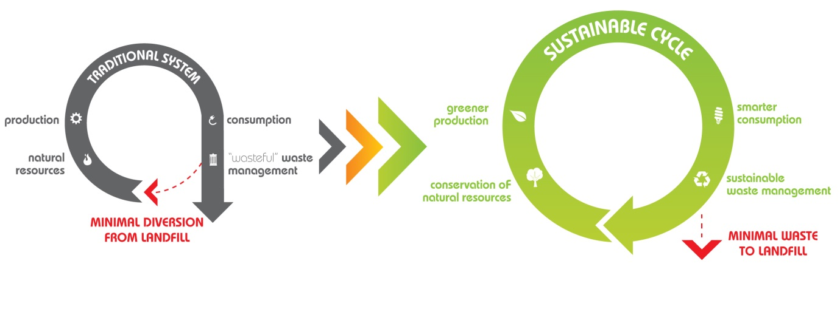

Diagram 1‑1: Sustainable Waste Management Cycle

# Murray River Council

## Location

The MRC encompasses an area of 11,865km2 with more than 11,500 residents living with the region. Located in the Southern Riverina region, 800km south west of Sydney and 205km north of Melbourne, the Murray River Region is a major component in the nation’s food and agricultural production.

MRC is bordered by the Murray River to the south and the Swan Hill, Gannawarra, Campaspe and Moira Councils within the State of Victoria. To the north and within NSW, MRC’s neighbouring Councils are Balranald, Hay, Edward River and Berrigan as shown in **Figure 2‑1.**

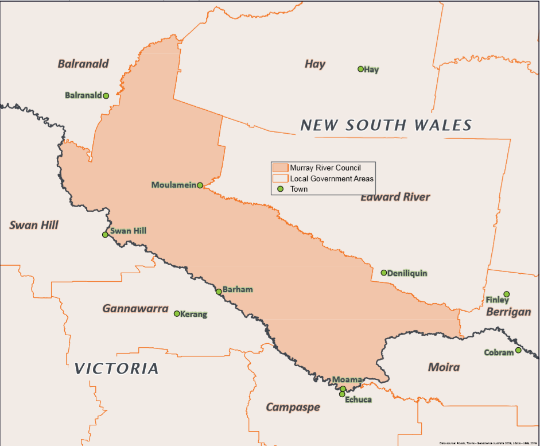

Figure 2‑1: MRC Location and Neighbouring Councils

## Demographics

Population data published by the Australian Bureau of Statistics (ABS) was utilised to understand past population trends within the MRC. **Diagram 2‑1** shows the population growth and distribution within the region from 2001 to 2016.

Diagram 2‑1: Recorded population within the region 2001-2016

It can be seen in **Diagram 2‑1**, the total population within the region increased from 10,689 to 11,680 from 2001 to 2016. This resulted in a growth rate of 0.6% over this time period. The figure highlights an unequal distribution of population growth amongst the Murray Shire and Wakool Shire prior to the amalgamation. The higher growth rate in the MRC is largely due to recent rapid growth in the township of Moama as shown in **Table 2‑1**.

Table 2‑1: Past Population Growth Rates

|  |  |  |  |  |
| --- | --- | --- | --- | --- |
|  | Moama | | Greater MRC | |
| Year | Population | Growth rate | Population | Growth rate |
| 2001 | 4, 243 |  | 10, 689 |  |
| 2006 | 5, 000 | 4% | 10, 779 | 0.2% |
| 2011 | 5, 364 | 1% | 10, 919 | 0.3% |
| 2016 | 6, 131 | 3% | 11, 680 | 1.4% |

Moama is considered to be one of the fastest growing municipalities in NSW. **Table 2‑1** highlights its higher growth rate in comparison to the remaining greater MRC area.

The ABS releases Estimated Resident Populations (ERP) data for regions in which detailed estimations are made for the populations of the region in each year over a designated period. Recorded and projected growth rates were sourced from the ABS and advice from the MRC respectively and projected to 2036 as summarised in **Table 2‑2**.

Table 2‑2: MRC Total Population Projections

|  |  |  |  |  |  |  |
| --- | --- | --- | --- | --- | --- | --- |
| Total Murray River | | | | | | |
| **TOTALS:** | **2011** | **2016** | **2021** | **2026** | **2031** | **2036** |
| Total Population | 11,250 | 11,550 | 12,272 | 13,010 | 13,816 | 14,698 |
| Total Households | 4,950 | 5,200 | 5,450 | 5,650 | 5,800 | 5,900 |
| **CHANGE:** |  | **2011-16** | **2016-21** | **2021-26** | **2026-31** | **2031-36** |
| Total Population Change |  | 300 | 722 | 737 | 806 | 882 |
| Average Annual Population Growth |  | -0.5% | 1.0% | 1.0% | 1.0% | 1.0% |

**Table** 2‑2 is supported via confirmation from MRC staff and estimated growth rates sourced from the NSW Department of Planning and Environment; Population and Household Projections (2016). The MRC has estimated that the Moama population will grow at a rate of 2% per annum and the greater MRC area to grow at 1% per annum. Based on these adopted growth rates, **Diagram 2‑2** outlines the results of the population projections for the Moama area and the greater MRC area.

Diagram 2‑2: Population Projections for MRC

As previously outlined, Moama is considered the growth area for the MRC which is further highlighted in **Diagram 2‑2.** Although the MRC is experiencing overall growth, it is anticipated that some areas within the MRC are experiencing no growth, which is offset by the strong growth in Moama.

## Key Industries

Traditionally, the key industries within the MRC are agriculture, forestry and fishing. Recently, the economy within the region has become more diverse with industry development occurring within the retail, construction, manufacturing, health care, landcare, professional services and local tourism sectors. Increase in these sectors has led to further opportunities of employment as alternative skill sets (from traditional industries) are sought.

## Infrastructure Strategy

The MRC Community Strategic Plan (2018-2028) highlights the MRC strategic action to improve and maintain community infrastructure as a result of increasing population within the region. This involves the development of roads, public facilities, community halls and long term planning for the increasing demand of river frontage properties. As population growth in unevenly distributed across the MRC, major infrastructure development will be required to cater for the growth in and surrounding Moama. Furthermore, the region has an aging population which requires MRC to deliver age-friendly infrastructure

# Legislative & Policy Framework

There are several State, National and/or International regulations, policies and guidelines relating to waste management which may have an impact on the MRC either currently or in the future. These documents have been reviewed and assessed in terms of their potential implications on the MRC’s current and future waste management operations.

## State

There are a number of NSW State legislative, policy, strategy, educational and economic tools relating to waste management in NSW. The State’s main legislation that impacts waste management includes the *Protection of the Environment Operations (POEO) Act 1997*, the *Waste Avoidance and Resource Recovery (WARR) Act 2001*, the *Protection of the Environment Operations (Waste) Regulation 2005* and the amended draft *Protection of the Environment Operations (Waste) Regulation 2017*. These main legislative documents describe the requirements for transporting, storing, processing, managing, recovering and disposing of waste and recyclable material.

*NSW 2021: A Plan to make NSW Number One* outlines a number of waste management related aspects within the following goals:

* Goal 22 - Protect our Natural Environment:
  + Reduce illegal dumping;
* Goal 23 - Increase opportunities for people to look after their own neighbourhoods and environments:
  + Reduce litter;
  + Achieve recycling targets;
  + Supports community recycling drop-off centres to provide locations for recycling and/or disposal of household hazardous wastes.

The *WARR Strategy 2014-2021* provides a framework for waste management until 2021 and aligns with the NSW Government’s waste reforms in *NSW 2021: A plan to make NSW number one.* The *WARR Strategy* sets to minimise waste, alter public behaviour through education and increase investment, innovation and improvement of environmental practices. In doing so WARR aims to achieve the following waste diversion from landfill targets in **Table 3‑1.**

Table 3‑1: NSW WARR Strategy diversion targets

|  |  |
| --- | --- |
| Waste Type | 2022 Diversion Target |
| Municipal Solid Waste (MSW) | 70% |
| Commercial and Industrial (C&I) | 70% |
| Construction and Demolition (C&D) | 80% |
| Overall Diversion from Landfill | 75% |

The *WARR Amendment (Container Deposit Scheme) Act 2016* established the Container Deposit Scheme (CDS) to reduce litter and recover, reuse and recycle drink containers. The CDS “Return and Earn” was introduced in 2017 facilitating a 10-cent refund for eligible containers when presented to a collection point. In NSW, eligible containers in kerbside recycling bins are also redeemable by Councils through an agreement with the Materials Recovery Facility (MRF) operator providing Councils with a source of revenue. However, this is not currently the case in Victoria.

## National

The National Waste Policy – *Less Waste More Resources* was released by the Department of Sustainability, Environment, Water, Population and Communities in November 2009 and provides a direction for waste in Australia to 2020 with a view to reduce waste generation and manage waste as a resource to deliver economic, environmental and social benefits. The National Policy sets eight outcomes for waste management by 2020. To achieve these outcomes, the Policy identifies six key directions which are supported by a series of objectives.

The six key directions stated in the Policy are:

* Taking responsibility;
* Improving the market;
* Pursuing Sustainability;
* Reducing hazard and risk;
* Tailoring solutions; and
* Providing the evidence.

The National Policy also recognises the important role of Councils in providing waste management services and infrastructure. The objective to “*support improved waste management and reuse of waste in regional, remote and Indigenous communities*” is supported by Strategy 14 which involves “*State and territory and local governments to work together to identify regional and remote waste and resource recovery actions to build capacity and ensure an appropriate suite of services is available to communities*”.

The Emissions Reduction Fund aims to reduce emissions by providing incentives for businesses, land owners, state and local governments, community organisations and individuals to adopt new practices and technologies. Legislation to implement the Emissions Reduction Fund came into effect on 13 December 2014.

There are many activities which are eligible to earn Australian Carbon Credit Units (ACCUs) under the scheme. One ACCU is earned for each tonne of carbon dioxide equivalent (tCO2-e) stored or avoided by a project. ACCUs can be sold to generate income, either to the Government through a carbon abatement contract, or on the secondary market.

The potential waste management activities that may earn ACCUs as part of the Emissions Reduction Fund are Alternative Waste Treatment (AWT), inclusive of composting, process engineered fuel manufacturing and landfill gas capture. Councils and/or private industry that undertake these types of projects in accordance with the approved Waste and Wastewater Sector emissions reduction methods can then sell the resulting emissions reductions to the Clean Energy Regulator.

The Landfill Gas Determination provides an incentive to install new landfill gas collection systems, upgrade existing systems or recommence operation of non-operational systems. The methane in the collected gas is then destroyed through combustion. ACCUs are given for the destruction of emissions from waste deposited after 30 June 2014.

## International

China has been a large international importer of recycled material from a variety of nations. As of January 1, 2018, China began restricting its acceptance of foreign waste. This restriction of waste is better known as the China National Sword Policy.

Many nations, Australia included, have relied on China to process and re-manufacture their waste. The recent alterations have left exporters of waste in turmoil. Waste exporting nations, like Australia, will need to develop their own infrastructure to process and recycle plastics and other materials. This will be a long-term development, refining the waste management industry nationally. Although the Sword is currently impacting the Australian recycling industry negatively the Waste Management Association of Australia (WMAA) views this restriction as an opportunity for the economy to better its waste practices and operate a circular economy. National and State Governments need to assist in managing the issue at hand, ensuring limited recyclable product enters landfills, prior to assessing long term infrastructure.

The NSW EPA is working in conjunction with Governments and industry partners to limit the impact of the Sword Policy on the national industry. Funding has been provided through the Waste Less, Recycle More initiative, enabling councils to offset the increasing cost of kerbside recycling, limiting increase of fees to rate payers, better tendering processes with respect to recycling and the community education programs aiming to limit contamination of kerbside recycling bins. Further funding is provided to increase the quality of recycled products currently being processed within Australia.

An intergovernmental task force has been further established by the State Government and led by the NSW EPA to seek long term strategic options to counteract the China National Sword Policy. In the interim the NSW EPA has responded to the policy by temporarily increasing limits on stockpiles of recyclable material with the aim to limit their disposal to landfill in order to meet stockpile restrictions.

The NSW EPA has established a Recycling Relief Fund to assist non-levy paying councils in offsetting the increased processing costs of recycling materials during the period 1 March – 31 August 2018. Councils whom lie within the levy paying region can apply for funding through the Better Waste and Recycling Fund. The fund provides support to improve recycling, reduce waste generation and recycling. There is strong emphasis on education and use of recycled products within the market.

Development on the China National Sword Policy and the NSW EPA, Local, State and National Government reactions and introduction of policies should be maintained throughout the year.

# The Circular Economy and Waste Management Hierarchy

## Circular Economy

The principles of the circular economy endeavour to create a system that is efficient and self-sustaining which results in very little or no waste. The method in which waste is collected, recycled and processed alters the value of the material either allowing it to re-enter the system or unfortunately preventing its reuse. To prevent waste generation, the lifecycle of a material would continue to circulate within the system whereby the maximum value from the material is extracted and then recovered to create new materials facilitating the commencement of its next lifecycle.

The concept of the circular economy is beneficial to both industry and the environment. It ensures that businesses are protected against the increasing risk of resource scarcity and decreasing dependency of finite materials. A circular economy saves energy, lowering carbon emissions, and avoids damage caused by utilising the Earth’s resources at an unsustainable rate.

The circular economy is an aspirational concept that will continue to drive improvement in many industries globally however, the adaptation of the circular economy to existing systems is largely difficult, time consuming and potentially quite costly. A more practical system may combine elements of the circular economy and align them with the implementation of the Waste Management Hierarchy resulting in a sustainable waste management cycle (**Diagram 1‑1**).

## Waste Management Hierarchy

The resource recovery options identified for assessment as part of this review have been considered in the context of the Waste Management Hierarchy. The Waste Management Hierarchy (**Diagram 4‑1**), is an internationally adopted principle and concept which lists waste management options in order of preference according to their sustainability and environmental impacts.

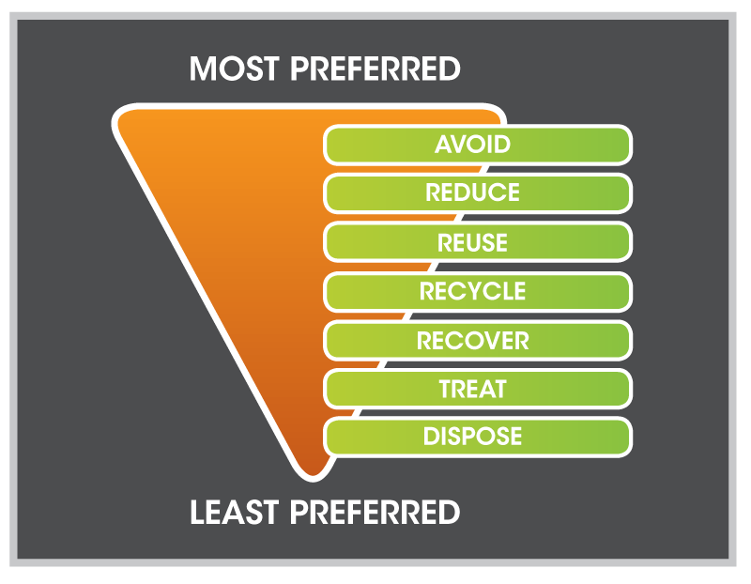

Diagram 4‑1: Waste Management Hierarchy

The Waste Management Hierarchy has been adopted within this report as the basis for classifying and assessing the various resource recovery options which are being considered to assist MRC improve its waste management system. As shown in **Diagram 4‑1** options which achieve outcomes higher up the Waste Management Hierarchy are preferred over those located further down the Hierarchy. Notwithstanding this, options from each level of the Waste Management Hierarchy have been identified and assessed.

The following sections provide a description of the various levels of the Waste Management Hierarchy. For the purposes of this project, the levels of the Hierarchy which are similar and/or complementary have been grouped.

## Avoid, Reduce, Reuse

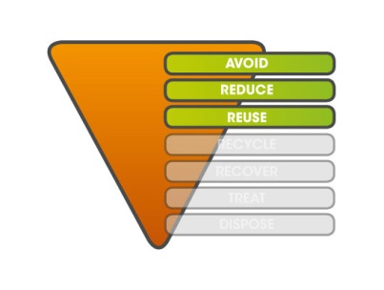Waste avoidance is the preferred practice and is greatly associated with sustainable design, production and consumption. After waste generation the next stage is minimisation. Waste avoidance and reduction are the most challenging aspects of waste management.

Reuse is considered the recovering of value from a discarded resource in its original state without reprocessing or remanufacture. Reuse can be achieved by an individual generator, or through the transfer of items or materials from a generator to another user through second hand sales.

## \\server\Talis\SECTIONS\Waste\Libraries\Images\Talis_Recycle.jpgRecycle

Utilising recycled products in manufacturing is environmentally beneficial as it reduces the demand for raw materials. In NSW, recycling has been widely adopted at a household level for packaging materials and household hazardous wastes. There are significant opportunities to increase recycling in the C&I and C&D sectors including organic mulching, inert waste crushing and screening.

Local governments have a significant role to play in the implementation of recycling practices including the collection, sorting and sale of materials, as well as education to encourage waste generators to utilise recycling systems.

## \\server\Talis\SECTIONS\Waste\Libraries\Images\Talis_Recover Treat.jpgRecover and Treat

Recovery of materials involves the physical, chemical or biological processing of waste to generate embedded products or energy. In contrast to recycling, the products generated from recovery processes are not necessarily similar to the original waste materials. Recovery often reduces the hazardous properties of the waste. The process is commonly undertaken at AWT facility which generate products and/or electricity or heat from sorted or mixed waste streams.

## Dispose

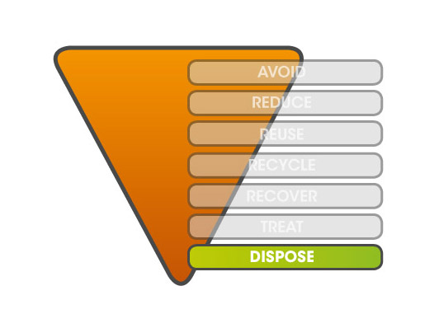Disposal typically involves landfilling and thus is the least preferred level of the hierarchy. In addition, it can include incineration without any energy or heat recovery such as thermal destruction of hazardous wastes. While it is inevitable that a small portion of waste will require disposal, it should be used as a last resort.

Waste disposal to landfill is the predominant method of managing waste within NSW and although the potential environmental impacts such as soil and water pollution and greenhouse gas generation may be minimised through the construction of best practice landfill facilities, landfilling inevitably results in a loss of materials and energy.

# Current Waste Management System

The MRC currently provides a variety of waste management programs and services. The following section outlines the waste management activities undertaken by MRC within each of the Waste Management Hierarchy groupings.

## Avoid, Reduce, Reuse

### Community Education

The MRC's website contains information on the waste services available to residents and businesses including:

* Kerbside collection schedules for Moama, Mathoura, Greater Wakool Ward and Rural regions;
* The opening hours of waste management facilities (WMFs);
* Contact numbers for the waste management operators; and
* Procedures for separation of recyclables from the refuse/residual stream at WMFs.

### Reuse Websites

There are a number of websites available which facilitate waste minimisation and reuse. These include:

* Facebook Community Group pages:
  + Murray River Area Buy N Sell;
  + Echuca Moama New Buy Swap Sell;
  + Tooleybuc Koraleigh & Surrounds Swap Buy & Sell; and
* ‘Gumtree’ which is an Australia-wide website for the advertisement of goods, services, accommodation and employment including sale and exchange of second-hand items.

## Recycle

### Kerbside Commingled Recycling

MRC currently offers a kerbside comingled recycling collection service to town centres and most rural areas. Of the 5,460 private dwellings within the region 4,163 are serviced (76%). The following localities receive a 240L mobile garbage bin (MGB) collected fortnightly:

* Mathoura
* Moama
* Barham
* Goodnight
* Koraleigh
* Moulamein
* Murray Downs
* Tooleybuc
* Wakool
* Bunnaloo
* Womboota

Outside of these serviced areas residents are responsible for the management of their own waste. Residents are encouraged to utilise the MRC’s WMFs for their recyclables and refuse. Additional to the residential households, 270 businesses participate in kerbside collection. The MRC currently has a contract with Veolia (previously Ellwaste) to provide the kerbside comingled recycling collection services. The contract is due to expire in mid-2019.

### Community Recycling Centres

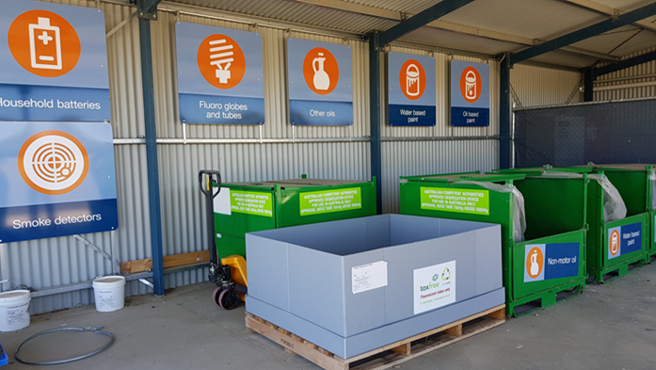Community Recycling Centres (CRCs) collect household problem wastes that aren’t available to be collected in kerbside collection such as:

* Paint;
* Gas bottles and fire extinguishers;
* Fluoro globes and tubes;
* Household and car batteries;
* Smoke detectors; and
* Motor and other oils.

Moama WMF operates as an established CRC where waste is consolidated and collected for recycling.

Figure 5‑1: Community Recycling Centre at Moama WMF

### Bulk Recycling Drop off

Recyclable packaging materials are commonly dropped off free of charge at WMFs across the MRC. The MRC accepts certain types of materials at their WMFs which are stockpiled prior to being consolidated and/or transported by a contractor for recycling purposes. Where possible recyclables should be stockpiled separately to increase waste handling efficiency. These materials include:

* Greenwaste;
* Scrap metal;
* Whitegoods;
* Inert concrete and bricks;
* Batteries;
* Waste motor oil and used oil drums;
* Tyres (not to exceed 50 tonnes at Moama WMF);
* Paints;
* Gas bottles; and
* E-waste.

In addition, MRC also accepts other materials including old chemical drums (through the Drum Muster program) at WMFs and mobile phones (through the Mobile Muster program) at old Wakool Shire Council office in Moulamein

### Waste Transfer Stations

Waste Transfer Stations (WTS) are facilities where separate waste streams such as refuse, C&D waste and organics are accepted and temporarily stored and/or sorted before being transported to another destination for further treatment and/or disposal. The MRC utilises WTSs as a form of waste management promoting segregation and recycling of waste resources by the public and businesses prior to undergoing further processing and treatment. Locations of WMFs within the MRC are show in **Figure 5‑2**.

Figure 5‑2: Waste Management Facilities Map

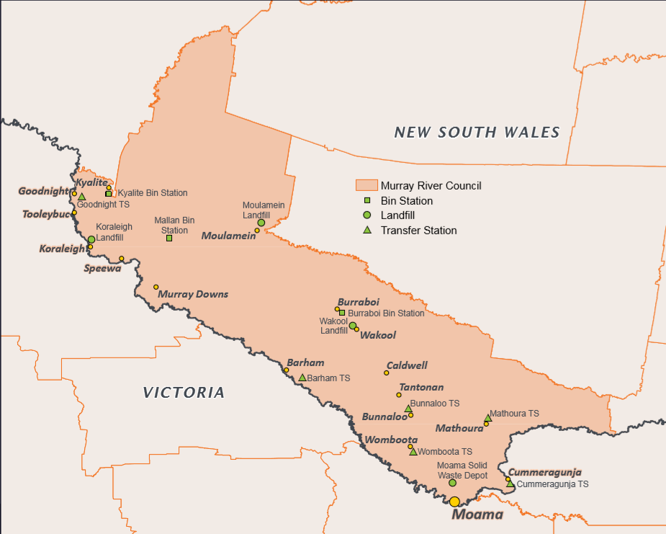Currently, the following waste transfer facilities, as seen in the figure above, are operated by the MRC:

* Barham Transfer Station – Lot 108 East Barham Road, Barham;
* Bunnaloo Transfer Station – Gipps Street, Bunnaloo Road Reserve;
* Cummergunja Transfer Station – off George Street, Cummergunja;
* Goodnight Transfer Station – Lot 2 Goodnight Road, Goodnight Lot;
* Mathoura Transfer Station - Lot 190 Clifton Street, Mathoura; and
* Womboota Transfer Station - Hopkins Street, Womboota Road Reserve.

Please note that landfill operations have ceased at Goodnight Landfill and Cummergunja Landfill, thus for the purpose of this review they will be analysed as a WTS. Each of the above-mentioned WTSs are described in further detail in the following sections.

The following figures depict some of the waste management practices occurring at sites throughout the MRC.

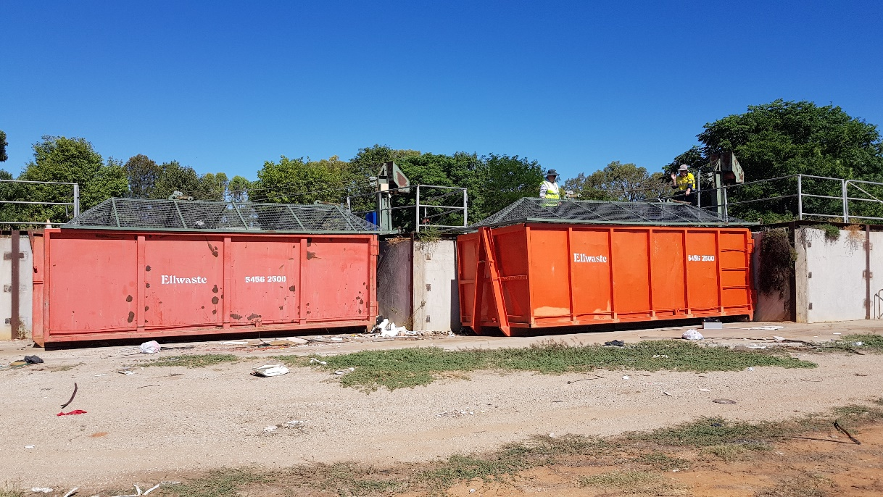

Figure 5‑3: Lidded hook-lift transfer containers arranged in a saw tooth

configuration at Barham WTS

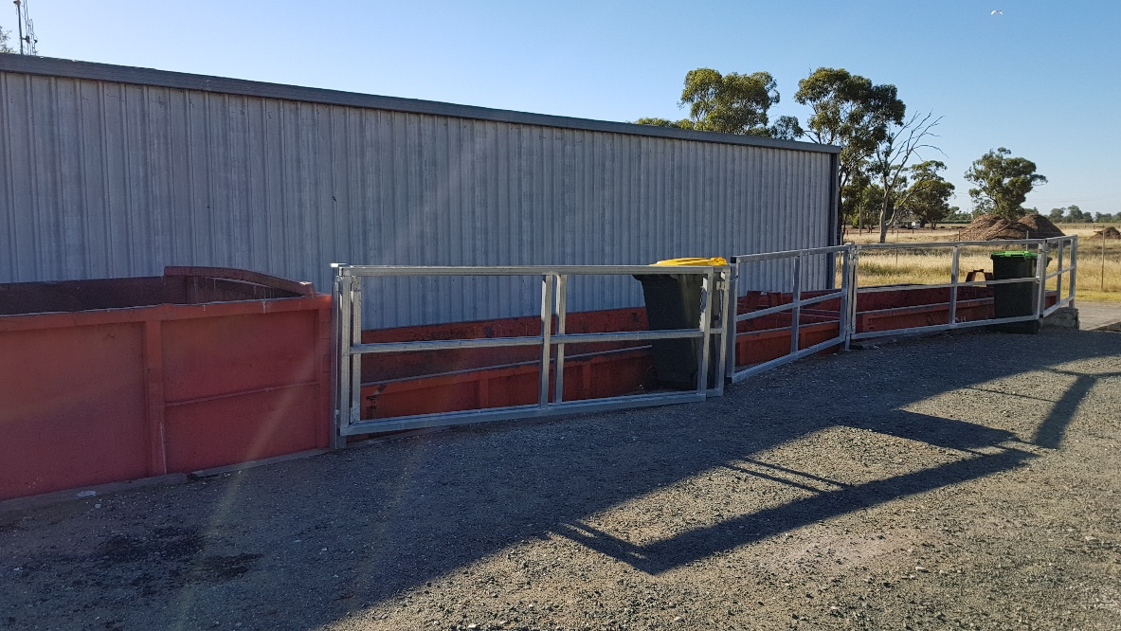

Figure 5‑4: Transfer containers at Mathoura WTS

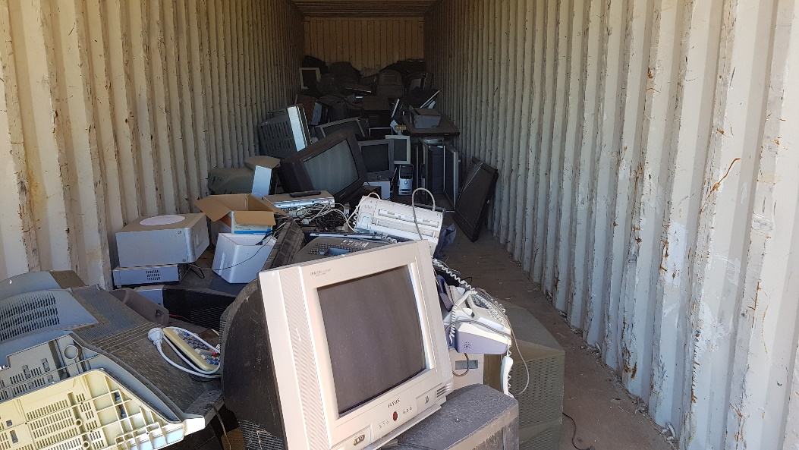

Figure 5‑5: Enclosed E-waste collection at Barham WTS

#### Barham

Barham Transfer Station is a fenced site offering manned supervision to the community of Barham two half days a week. Community members are able to deposit domestic waste which is then transported to a private landfill in Cohuna, Victoria. Additional to domestic waste the site accepts domestic oil quantities, masonry products, greenwaste, paper/cardboard, drums, scrap metal and E-waste.

The site is established with two 30m3 hook-lift transfer containers where community members directly deposit domestic waste. The containers are fitted with caged lids ensuring the safety of the community and prevention of windblown litter. The containers are laid out in saw tooth configuration creating ease and efficiency of waste removal.

A large locked building at the site provides an enclosed area for the storage of MRC equipment. It is understood that dismantling of E-Waste occasionally occurs within the building. An enclosed container for the storage of E-Waste facilitates the consolidation and removal of E-waste for further processing in the Melbourne metropolitan area.

Barham transfer station has clear signage provided by the Environment Protection Authority (EPA) indicating drop off locations for the various materials accepted at site.

#### Cummergunja

Cummergunja is an old landfill which has been redeveloped as a waste transfer station for the Aboriginal Community in the land of the Yorta Yorta nation. Arrangements are currently being made to establish a split-level disposal area on site.

#### Bunnaloo

Bunnaloo transfer station is designed to cater for the small rural community of Bunnaloo and is unmanned and unfenced. Located on an unused road easement, the Bunnaloo transfer station contains an unlocked bin storage structure for the public to segregate and deposit recycling. Although the concept of segregation is present, the unmanned site is abused which results in litter issues and additional clean-up expenses. The Bunnaloo site accepts recyclables, used chemical drums and domestic waste which is directly deposited into three 3m3 bins provided by the contractor. A small accumulation of white goods is also present at the site.

#### Goodnight

The Goodnight WMF is currently classed as a landfill operated by Cleanaway. However, it ceased landfilling and in turn has commenced WTS operations via several front-lift bins which has prompted its classification as a WTS for the purposes of this review. The Goodnight transfer station is manned and operated one day per week. The site mainly receives domestic waste which is directly disposed into two 3m3 bins provided by the contractor. The layout of the site promotes the separation of the community and operational aspects via a service road accessible behind the front lift bins.

#### Mathoura

Mathoura Transfer Station is a securely fenced site offering manned supervision to the community of Mathoura three days a week. Community members are able to deposit recyclables and residual waste. The site provides a split level tipping area for residual waste into one 24m3 and two 18m3 hook lift containers supplied by the contractor which are transported to the Moama WMF. These containers are currently arranged linearly which has reduced operational efficiency to that of a saw tooth configuration. The site is additionally fitted with 12 x 240L MGBs for the collection of Co-mingled recyclables. Mathoura WTS also accepts oil, masonry products, greenwaste, paper/cardboard and scrap metal.

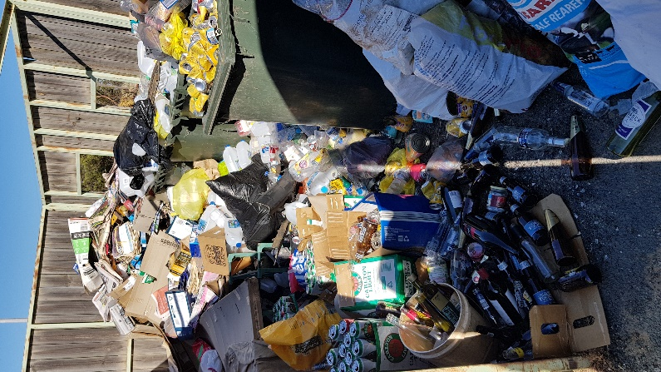

Figure 5‑6: Poorly segregated comingled recycling at Bunnaloo bin station

Signage at the entrance to the site notifies users that all larger quantities of waste are to be taken to Moama WMF. However, it is understood that some commercial volumes of waste continue to be deposited at Mathoura in a potentially unsafe manner.

#### Womboota

Similar to Bunnaloo, the small Womboota transfer station is unmanned, unfenced and has litter issues as a result of overflowing receptacles and unmanaged stockpiles of larger recyclables, wastes and tyres. There are three 3m3 front lift bins provided by the contractor for refuse which is collected periodically or as required.

### Recycling Bin Station

The MRC provide a comingled recycling bin station in the township of Burraboi which accepts commingled recyclables in a custom-built hook-lift receptacle. The recycling bin station is provided free of charge by a local recycler.

### Bulk Materials Processing

The MRC currently contracts greenwaste mulching services to a private contractor. When required the contractor travels to each WMF to mulch the greenwaste stockpiles. The mulched greenwaste is then given away or utilised by MRC on parks and gardens. Reprocessing is considered the most desirable option for greenwaste.

Another bulk material that is commonly identified as suitable for processing is C&D waste, such as concrete and bricks. C&D processing is a costly exercise with most contractors suggesting that a sufficient volume (approximately 10,000m3) needs to be achieved before processing is a viable option. Once processed, these recycled building products have a variety of applications including use as road base, drainage aggregate or fill material. MRC has significant stockpiles of C&D materials at several of its WMFs ready for crushing and screening.

## Recover and Treat

There are currently no recovery or treatment initiatives being undertaken by the MRC however, a private operation located near Echuca, VIC currently converts cooking oil into biodiesel.

## Dispose

The MRC’s current disposal infrastructure network and services are described within the following sections.

### Kerbside Residual Collection

MRC currently offers a residual kerbside collection to all residents and commercial businesses that receive a comingled kerbside collection with the bin sizes and collection frequencies outlined in **Table 5‑1**.

Table 5‑1:Kerbside Residual Collection

|  |  |  |  |
| --- | --- | --- | --- |
| Locality | Bin Size (Residual) | Collection Frequency | |
| Mathoura  Moama | 140 L | Weekly |
| Barham  Goodnight  Koraleigh  Moulamein  Murray Downs  Tooleybuc  Wakool | 120 L | Weekly |
| Bunnaloo  Womboota | 240 L | Fortnightly |

Outside of these serviced areas residents are responsible for the management of their own waste. Residents are encouraged to utilise the MRC’s WMFs for their recyclables and refuse.

The MRC provides 140, 240 L public place bins throughout the region. The MRC provides residual bin stations at Kyalite and Mallan. Each site collects a small quantity of waste via 3m3 front lift receptacles provided by the Contractor. Bins are collected infrequently as required and service a small percentage of the MRC’s population.

### Waste Disposal

The MRC relies on landfilling for the majority of its waste disposal requirements. The following operating landfill facilities are present within the MRC and are described in further detail in the following sections:

* Koraleigh Landfill – No. 2 Lot 2 Angle Road, Koraleigh;
* Moulamein Landfill – Lot 132 Tchelery Road, Moulamein;
* Moama Landfill – Lot 211 Centre Road, Moama; and
* Wakool Landfill – Lot 9 Wakool Road, Wakool.

It is recognised that landfilling is the least preferred method for waste disposal however, following resource recovery it is typical that a small portion of residue waste will always require landfilling.

#### Koraleigh

Koraleigh Landfill site is a fenced site offering manned supervision of waste disposal to the public two half days per week. The landfill is situated in an ideal location to service the western portion of MRC. Currently the landfill operations are contracted to a separate business to the one that operates Moama Landfill. A separate contract causes more complexity in contract management and potentially reduces the accountability of the contractor when scrutinised.

There is a small gatehouse at the entrance to the site which facilitates the recording of data and directional information for users of the site. There is basic recycling of greenwaste, scrap metal, domestic quantities of oil, paper/cardboard, batteries glass and E-waste undertaken at the site. For refuse disposal, the community unloads into two 3m3 front-lift containers which are taken to the landfilling area periodically when a front-lift vehicle is at the site. The community recycling and disposal area at the front of the site is completely separated from the landfilling areas which minimises the risk to public safety associated with the landfilling practices. However, there are two separate landfilling areas located onsite with the main landfill in the south west of the site and another situated to the north west of the community area. Greater visibility of the operations and ongoing site developments would ensure that the site is utilised to its maximum efficiency while also minimising its environmental impact.

#### Moama

Moama WMF site is MRC’s only licenced landfill and operates seven days per week. All incoming waste enters via weighbridge where waste is categorised and quantified. The landfill receives a large portion of C&I and C&D waste from outside the MRC’s jurisdiction. The acceptance of this waste creates a beneficial revenue stream for MRC however, it consumes landfill airspace, is difficult to sort or separate recyclables and negatively effects MRC’s overall waste diversion rate.

Moama WMF has a structured approach to landfill cell establishment and operation governed by the conditions within its Environmental Protection License (EPL). This includes the provision of compacted clay leachate barrier systems to prevent groundwater contamination, compaction and the daily covering of waste. The site has a weighbridge, a covered structure for segregated recycling purposes, sealed roads and carpark areas to manage higher traffic flow and minimise dust generation. The site conducts basic recycling of greenwaste, C&D, scrap metal, domestic quantities of oil, paper/cardboard, batteries, glass, E-waste, smoke detectors, fluorescent globes and oil-based paints. The design of Moama WMF allows for a future community drop off centre to be established near the existing CRC and entrance of the site as this area has been reserved for this purpose and will not be landfilled.

#### Moulamein

The Moulamein landfill site is a fenced site with manned supervision of waste disposal two half days per week. The site contains staff amenities and is fitted with speed limit signs and clear and consistent segregation signage to identify the varying areas for recycling and/or disposal. The site caters for recycling of greenwaste, scrap metal, domestic quantities of oil, paper/cardboard, batteries, glass and E-waste. There are two separate landfilling areas; one which is surrounded by litter fencing and is an above-ground operation and another located in a trench adjacent to the litter fencing. Both landfill areas are covered to prevent windblown litter whenever possible.

#### Wakool

Wakool landfill is open two half days per week to the public and is manned during this time. A staff area is provided along the entrance road to the site for operatives to greet customers, record data and provide directions for unloading of recyclables or waste. Wakool landfill conducts basic recycling of greenwaste, scrap metal, domestic quantities of oil, paper/cardboard, batteries, glass and E-waste. Recyclables are stockpiled, and drums are placed into the DrumMuster fenced area. General waste is directly unloaded into trenches which is covered to prevent windblown litter occasionally.

## Summary of Waste Management Facilities

Waste management facilities distributed throughout the MRC are shown previously in **Figure 5‑2** and provided in **Table 5‑2** with an overview of key characteristic.

Table 5‑2: Summary of WMFs Characteristics

|  |  |  |  |  |  |  |  |  |  |  |
| --- | --- | --- | --- | --- | --- | --- | --- | --- | --- | --- |
|  | Operator | Licenced | Fenced | Landfilling Style | Gatehouse | Weighbridge | Nearest Sensitive Receptor | EPA Signage | CRC | Groundwater Monitoring |
| **Landfills** | | | | | | | | | | |
| **Koraleigh** | Cleanaway | 🗶 | ✓ | Above Ground | ✓ | 🗶 | 950m | 🗶 | 🗶 | 🗶 |
| **Moama** | Veolia | ✓ | ✓ | Above Ground | ✓ | ✓ | 605m | ✓ | ✓ | ✓ |
| **Moulamein** | MRC | 🗶 | ✓ | Above Ground | ✓ | 🗶 | 430m | ✓ | 🗶 | 🗶 |
| **Wakool** | MRC | 🗶 | ✓ | Trench | ✓ | 🗶 | 507m | 🗶 | 🗶 | 🗶 |
| **Transfer Facility** | | | | | | | | | | |
| **Barham** | MRC | 🗶 | ✓ | NA | ✓ | 🗶 | 560m | ✓ | 🗶 | 🗶 |
| **Bunnaloo** | Unmanned | 🗶 | 🗶 | NA | 🗶 | 🗶 | 100m | 🗶 | 🗶 | 🗶 |
| **Goodnight (former landfill)** | Cleanaway | 🗶 | ✓ | NA | ✓ | 🗶 | 970m | 🗶 | 🗶 | 🗶 |
| **Mathoura** | Veolia | 🗶 | ✓ | NA | ✓ | 🗶 | 340m | 🗶 | 🗶 | 🗶 |
| **Womboota** | Unmanned | 🗶 | 🗶 | NA | 🗶 | 🗶 | 90m | 🗶 | 🗶 | 🗶 |
| **Bin Station** | | | | | | | | | | |
| **Burraboi** | NA | 🗶 | 🗶 | NA | 🗶 | 🗶 | 50m | 🗶 | 🗶 | 🗶 |
| **Kyalite** | NA | 🗶 | 🗶 | NA | 🗶 | 🗶 | 20m | 🗶 | 🗶 | 🗶 |
| **Mallan** | NA | 🗶 | 🗶 | NA | 🗶 | 🗶 | 30m | 🗶 | 🗶 | 🗶 |

It can be seen from **Table 5‑2** that the MRC has a range of WMF types, each with varying degrees of operational standards and practices. In addition, MRC engages multiple contractors to operate different sites which creates further contractual and operational issues. In contrast, some WMF sites and the bin stations are unmanned which leads to unmanaged and uncontrolled waste disposal which increases MRC’s exposure to environmental risks.

It is recommended that all Bin Stations (Burraboi, Kyalite and Mallan) are removed by contacting the neceesary contractor as soon as possible.

# Waste Data

The following section presents data on the current waste management systems across the MRC, including:

* Current quantities of the various materials generated and/or processed in the MRC;
* Typical compositions of the key waste streams;
* Performance of recovery rates against targets; and
* Projections of future waste generation within the MRC.

## Current Waste Generation

The MRC generates 20,738 tonnes of waste within the 2016/17 financial year with future waste generation expected to increase and align with population growth.

All waste managed by the MRC is brought to a WMF and is processed in one of the following methods:

* Stockpiled on site for recycling;
* Stockpiled for future recovery or treatment; or
* Disposed to landfill.

As only Moama WMF has a weighbridge, data is recorded at other WMFs based on volumetric estimates or unit quantities. In these cases, tonnages have been calculated based on the gatehouse records and conversion factors.

The quantities of materials accepted for stockpiling prior to off-site recycling and/or disposal at each of the landfills and WMFs are shown in **Table 6‑1** and **Table 6‑2.**

Table 6‑1: Waste Deposited at Landfills (2016 data)

|  |  |  |  |  |
| --- | --- | --- | --- | --- |
|  | Moama | Koraleigh | Wakool | Moulamein |
| MSW Dropoff | 50 | - | 10 | - |
| MSW Kerbside | 1,843 | 685 |  |  |
| Recycling Dropoff | 75 | 1 | 6 | 6 |
| Recycling Kerbside | 661 | 12 | 28 | 17 |
| Greenwaste | 23 | 44 | 50 | 13 |
| C&I | 11,604 | 1,601 | 15 | 27 |
| Scrap Metal | 17 | 8 | 6 | 13 |
| C&D | 1,776 | 402 | 10 | 18 |
| Total | **16,049** | **2,753** | **124** | **93** |

Table 6‑2: Waste Deposited at Waste Management Facilities (2016 data)

|  |  |  |  |  |  |  |
| --- | --- | --- | --- | --- | --- | --- |
|  | Barham | Bunnaloo | Mathoura | Burraboi | Goodnight | Mallan |
| MSW Dropoff | 98 | 0.36 | 127 | 0 | 9 |  |
| MSW Kerbside | 10 | 0 | 0 | 2 | 2 | 9 |
| Recycling Dropoff | 113 | 0 | 0 | 0 | 16 |  |
| Recycling Kerbside |  |  |  |  |  |  |
| Greenwaste | **0** | 0 | 0 | 0 | 0 |  |
| C&I | **0** | 0 | 0 | 0 | 9 | 0 |
| Scrap Metal | **0** | 0 | 0 | 0 | 0 | 0 |
| C&D |  |  |  |  |  |  |
| Total | **221** | 0.36 | 127 | 2 | 35 | 9 |

It can be seen from **Table 6‑1** that Moama WMF accepts a significant quantity more than the other landfills. In particular, 11,600 tonnes of C&I waste contributes the largest portion of the overall waste accepted at the site. In addition, Koraleigh accepts a small quantity of C&I waste whereas, both Wakool and Moulamein landfills do not accept much material at all. **Table 6‑2** shows that of the WTSs, Barham and Mathoura accept the largest quantities of waste or recycling materials, with a small quantity accepted at Goodnight. The other facilities accept very little material on an annual basis. There is no data recorded for the material accepted at Womboota Transfer Station or Kyalite bin station and therefore were not included in the above table.

## Waste Streams and Composition

In addition to the quantitative data, an understanding of the composition of the waste generated within the MRC is an important aspect in the consideration of potential resource recovery options to assist in the improvement of MRC’s waste management system. Waste audit data was available for the former Murray Shire Council; similar composition was estimated for the remainder of the current MRC. Compositional data from other areas in NSW and reports formulated by the NSW EPA have been used to provide an indication of the types and proportions of materials generated from each waste stream. As will be outlined within **Section 6.4**, these data sets have been used to estimate the current and potential future quantities of various waste materials which is key to understanding the potential feasibility of implementing either Resource Recovery or Disposal Options to manage certain materials.

### Kerbside Residual

To obtain a typical composition for MSW within the MRC, it has been necessary to use data from a review of kerbside recycling collection systems within rural NSW, provided by the Murray Shire Waste Audit conducted by MRA Consulting Group in 2014 (*Waste Audit*). Obtained data was combined to produce a typical composition of MSW as outlined within **Diagram 6‑1.**

Diagram 6‑1: Kerbside Residual Composition

Murray Shire Council Waste Audit; Results Report (2014)

As shown in **Diagram 6‑1**, the MSW refuse stream contains mainly food/kitchen waste, greenwaste and paper and cardboard which represents approximately 84% of the MSW stream.

A reduction of organics entering landfills would go some way to increasing the MRC diversion rates and longevity of landfill sites. This may be done through source separation and the introduction of a third bin system. This would allow for organics, food and garden waste to be processed at alternate facilities rather than disposed to landfill.

### Kerbside Recycling

No comprehensive audits of kerbside recycling has been undertaken by the MRC thus compositional data was retrieved from *the NSW EPA (Domestic Kerbside Waste and Recycling in NSW 2011 waste audits)* providing the following composition for Regional Regulated Areas (RRA), now referred to as Regulated Levy Areas (RLA). Although the MRC is not included in the RLA, it is anticipated the RLA waste composition provides a close representation of the composition of kerbside waste within the MRC and is shown in **Diagram 6‑2.**

Diagram 6‑2: Kerbside Recycling Composition

*NSW EPA, Domestic Kerbside Waste and Recycling in NSW (2011)*

It is evident from **Diagram 6‑2** that paper and paper products and glass contribute largely to the composition of recycling waste with 50.05% and 34.17% recorded respectively.

### C&I

Data for C&I waste composition was sourced from the NSW EPA, Domestic Kerbside Waste and Recycling in NSW (2011). The following data sets (**Table 6‑3**) were analysed for RLAs.

Table 6‑3: C&I Composition Regional Levy Areas

|  |  |  |  |  |  |  |  |  |  |  |  |  |  |  |  |  |  |  |  |  |  |  |  |  |  |  |  |  |  |  |  |  |  |  |  |  |  |  |  |  |  |  |  |  |  |  |  |  |  |  |  |  |  |  |  |  |  |  |  |  |  |  |  |  |  |  |  |
| --- | --- | --- | --- | --- | --- | --- | --- | --- | --- | --- | --- | --- | --- | --- | --- | --- | --- | --- | --- | --- | --- | --- | --- | --- | --- | --- | --- | --- | --- | --- | --- | --- | --- | --- | --- | --- | --- | --- | --- | --- | --- | --- | --- | --- | --- | --- | --- | --- | --- | --- | --- | --- | --- | --- | --- | --- | --- | --- | --- | --- | --- | --- | --- | --- | --- | --- | --- |
| |  |  | | --- | --- | | C&I Composition RLAs | | | | Material | **% of waste stream** | | Garbage bags | 34.30% | | Wood | 15.10% | | Masonry | 10.70% | | Plastic | 8.60% | | Other | 8.20% | | Cardboard | 5.30% | | Paper | 4.20% | | Textiles | 4.00% | | Food | 3.30% | | Garden organics | 2.80% | | Metals | 1.70% | | Glass | 0.80% | | Rubber | 0.60% | | Electrical | 0.30% | | Total | 100% | | |  |  | | --- | --- | | Garbage Bag Composition in C&I Waste within RLAs | | | | Material | **% of waste stream** | | Food | 32.60% | | Paper | 22.10% | | Plastic | 21.40% | | Other | 7.20% | | Glass | 4.50% | | Cardboard | 4.10% | | Textiles | 3.70% | | Metals | 2.70% | | Masonry | 0.60% | | Rubber | 0.50% | | Garden organics | 0.30% | | Electrical | 0.10% | | Wood | 0% | | Total | 100% | |

It is evident that of C&I loads deposited to landfill sites a large portion of waste is still retained in garbage bags. Composition within the garbage bags is largely food, paper and plastic materials which is mostly recoverable. Recycling and/or organics bins provided to respective businesses (offices and/or hospitality sectors) could reduce this high percentage or recoverable materials within the C&I stream thus increasing MRCs landfill diversion rate.

### C&D

It is anticipated that C&D stream is consistent in composition in both metropolitan and regional areas, containing mostly inert materials such as concrete, bricks and soil/sand. If uncontaminated, this material has a high potential to be recycled into products such as road base and aggregates. The typical composition of the C&D stream recorded by the former Department of Environment & Climate Change NSW (2005), now the Office of Environment & Heritage NSW, through an analysis of Sydney C&D data is available in **Diagram 6‑3**. It was predicated that the C&D waste composition accepted at MRC WMFs would be similar.

Diagram 6‑3: C&D Composition

*Department of Environment & Climate Change, Report into the   
Construction and Demolition Waste Stream Audit (2000-2005)*

From **Diagram 6‑3** it can be seen that concrete (23%), Fines (21%) and Timber (20%) are the dominating elements of the C&D compositional data from the audit conducted.

## Diversion Rate

Diversion rate is defined as the proportion of total waste generated that is recovered, either through reuse, recycling or treatment, and is therefore diverted from landfill. MRC’s current diversion rate is shown in **Diagram 6‑4.**

Diagram 6‑4: MRC Diversion Rate

It can be seen from **Diagram 6‑4** that MRC currently recovers approximately 30% of the waste materials that are generated by its residents. MRC offers bulk recycling drop off and kerbside recycling collections to its residents which provides the basis for its recovery rate performance.

The diversion performance is based on the exclusion of C&I waste which is largely not generated by the residents and therefore, MRC has minimal influence over its diversion potential. If the C&I waste is included in the landfill diversion calculation, MRC’s total diversion rate is 27%.

### Targets

#### Riverina and Murray Regional Organisation of Councils Waste Diversion Targets

Interim targets were adopted by the Riverina and Murray Regional Organisation of Councils (RAMROC) to assist the region in achieving the NSW EPA WARR targets outlined in **Section 6.3.1.2.** A key focus area was to divert more waste from landfill with RAMROC members aiming to achieve a regional resource recovery rate of 50% by 2021 which was seen as an interim achievable target.

#### NSW EPA Waste Diversion Targets

The WARR Strategy 2014-2021 provides a framework for waste management until 2021 and aligns with the NSW Government’s waste reforms in NSW 2021: A plan to make NSW number one. The WARR Strategy sets to minimise waste, alter public behaviour through education and increase investment, innovation and improvement of environmental practices.

MRC’s performance against the Waste Diversion Targets set by the NSW EPA in the WARR Strategy are provided in **Table 6‑4.**

Table 6‑4: WARR Waste Diversion Targets

|  |  |  |
| --- | --- | --- |
| Waste Type | MRC Diversion Rate | 2022 Diversion Target |
| MSW | 19% | 70% |
| C&I | 25% | 70% |
| C&D | 60% | 80% |
| Overall Diversion from Landfill | 27% | 75% |

It is evident through comparing the MRC current diversion rate and the WARR 2022 diversion targets that MRC is underperforming with respect to landfill diversion. The MRC is significantly below the MSW and C&I targets. The diversion rate is heavily influenced by the significant quantity of C&I waste which at a diversion of 25% reduces the overall diversion to 27% even though C&D waste diversion is 60%. In contrast, if the C&I waste stream is removed from the calculation, MRC has a resulting waste diversion rate of 30% which, although an increase, is still well below the target diversion rates.

Increasing the diversion of MSW from landfill should be a focus of MRC leading to 2022 as this stream can be most influenced by MRC.

## Waste Projections

It is anticipated that waste generation is expected to increase in the coming years with several factors attributing to its projected growth. MSW generation was assumed to grow in proportion with the proposed population growth rates within the MRC, 2% growth for the Moama area and 1% for the remaining greater MRC area. Exterior factors beyond population affect the generation of C&I and C&D waste such as the economy, business and development approvals all which have been on the increase in the Moama area recently. **Diagram 6‑5** projects the waste tonnage generation for a 20 year period for each waste stream including the total.

Diagram 6‑5: Waste Tonnage Projection

From **Diagram 6‑5** it can be seen that waste tonnage increases over the forthcoming 20 year period. Total waste tonnage increases from 21,444 (2017) to 30,979 (2037). This increase in tonnage equates to an overall increase of 2.2% per annum for the MRC. In addition, it can be seen that the C&I waste stream has the most significant influence on both the total waste generation and the rate of increase.

# Resource Recovery Options

The following section identifies a variety of potential Resource Recovery Options across the various levels of the Waste Management Hierarchy to assist the MRC in progressing towards a more sustainable waste management system.

## Avoid, Reduce, Reuse

### Reuse and Tip-Shops

Reuse Shops are where small quantities of reusable materials are collected, stored, given minor improvements and presented for sale, generally available to the community for free or a minimal fee. The MRC does not currently operate any Reuse Shops at any of its WMFs.

The MRC could facilitate the establishment and operation of dedicated Reuse Shops at waste transfer and landfill sites. Presentation is a key factor in the success of a Reuse Shop, with attractive and well organised shops more likely to encourage use and improve the quality of the items received. Reuse Shops generally include a shed for the storage of items that need to be held indoors, as well as a forecourt area for larger, outdoor items. A consistent approach to the layout, signage and receptacles at the Reuse Shops would ensure a greater uptake of the service and increase the reuse of materials that may have traditionally been sent to landfill. This would ultimately assist in increasing the longevity of landfill sites through waste diversion. Additionally, this can provide beneficial community waste education practices while creating a revenue stream for MRC.

### Integrated Community Education and Behavioural Change Programs

Providing waste education is a key factor in the success of a waste management system and is important in supporting existing and new waste management services. The best performing waste management systems are supported by strong waste education programs. Information provided within a Waste Education Program should cover the following two key questions:

* ***Why?*** Outlining the benefits of sustainable waste management practices and environmental justification for undertaking such activities; and
* ***How?*** How the community can participate in waste management services provided.

Waste education usually focuses on initiatives at the top of the Waste Management Hierarchy (Avoid, Reduce, Reuse and Recycle) as well as informing on the particular services provided. For maximum benefit, an education program should be directed not only to local residents but also local businesses and contractors.

As part of the waste education program, a behaviour change communications plan could be developed for the MRC to focus on waste reduction and recycling. If MRC is able to undertake a study on behaviour change, they may be able to gain understanding of how challenging an individual’s social standard behaviour through pro-environmental behaviour change interventions can assist in encouraging long-term sustainable behaviour change (Nix, 2014).

There are numerous behavioural change models and methods that could be utilised by the MRC. An example of a successfully implemented behaviour change model was that developed by the Department for Environment, Food and Rural Affairs (Defra) in the UK. The ‘4Es model‘ focuses on four key elements, namely Enable, Encourage and Engage people to help them towards achieving sustainability and for the organisation leading the change to Exemplify, or lead by example **Diagram 7‑1** illustrates the concept of the 4Es behavioural change model.

Diagram 7‑1: The 4Es Behavioural Change Model

*Source: Diagram developed by Talis Consultants from Defra and Waste Authority (WA) information.*

Another example is the Doug McKenzie-Mohr method of promoting sustainable behaviour through community based social marketing which focuses on the belief that behavioural change is most effective when undertaken at the community level, with direct contact with the target audience (McKenzie-Mohr, 2000).

### Commercial Waste Minimisation Practices

#### Education

Providing information to commercial business operators to improve their waste management practices should be undertaken to:

* Educate businesses to be smarter with their operations in relation to waste management;
* Inform businesses of the waste management services available; and
* Obtain support for larger waste management initiatives.

The MRC could facilitate greater communication with the local commercial sector, with a focus on practices from the upper tiers of the Waste Management Hierarchy. This should include promoting the financial benefits of practices such as reducing oversupply, reuse of materials and separating recyclable waste streams to reduce disposal costs. The MRC may wish to consider incorporating these activities into the role of a Waste Education Officer who would run a campaign targeted towards commercial operators.

#### Financial Incentives

The *Return and Earn*, Container Deposit program, involves small reimbursements for the return of recyclable packaging materials to a designated collection point. This facilitates and promotes the reduction of litter and provides a small financial incentive for community groups (and residents) to make revenue. Partnering with commercial companies and community groups to promote the Return and Earn program can assist in waste reduction to MRC WMFs.

The MRC may also consider implementing a tax or ban on plastic bags to encourage the use of reusable bags. Although the tax would be imposed by the MRC, it is important to recognise that initiatives such as this can only be successful with the support of local businesses.

In addition, another financial incentive to reduce waste and increase source separation would be to increase commercial gate fees at the WMFs. This will result in the commercial sector becoming more innovative in ways of minimising waste production, separating recyclable materials to reduce volumes going to landfill and hence reduce their disposal costs.

#### Procurement and Approvals

MRC could also influence commercial practice through its procurement and approval processes. For tendered local government projects, the MRC could stipulate a requirement to prepare a Waste Management Plan, with the focus on maximising the diversion of materials from landfill. In addition, the MRC could also specify the requirement to utilise recycled products in projects, which will assist with the advancement of local recycling markets. This can be particularly relevant to construction projects. Furthermore, the MRC could require the preparation of Waste Management Plans for proposals seeking planning approval. These Waste Management Plans should maximise the diversion of materials from landfill, while also ensuring appropriate management systems are in place for all waste arising. Similarly, this could lead to significant waste diversion on larger construction projects.

### Waste Education Officer

As previously outlined in Section 5.1.1, providing waste education is a key factor in the success of a waste management system and the role of the Education Officer is paramount in the facilitation and delivery of any integrated waste education program. An Education Officer would provide the means for the MRC to present a consistent waste education message across all the towns within the MRC and develop closer partnerships between industry, towns and communities.

The Waste Education Officer would be responsible for gaining community acceptance and support for new waste management services to assist the MRC to move towards a more sustainable waste management direction. In particular the Waste Education Officer will manage the delivery of the Integrated Community Waste Education and Behavioural Change Programs and Commercial Waste Minimisation Practices. It is important that engagement by the Waste Education Officer with the community is undertaken early to increase the chances of success for the Resource Recovery Options and increasing waste diversion from landfill.

Consideration should be given to cooperating with surrounding Councils and/or RAMROC to implement a coordinated regional waste education program. This could include using common messages, resources and Waste Education Officers.

### Mobile Apps

There are a number of mobile device applications (apps) available to the MRC for use in promoting waste education and best practice waste management to the community.

Waste and recycling apps are currently being used by other councils throughout Australia as an alternative to the annual waste management services flyer sent to residents. It allows residents to keep track of bin collection days, be informed of what goes into the bins, access frequently asked questions, report issues and request additional bins or alter their waste services. The app can be further used to request a verge side collection (if provided) and allow MRC to provide residents with updates and/or news regarding their services. This is particularly useful when public holidays fall on collection days.

### Free Trade Websites

The Free Trade website is a tool for the public and businesses which promotes the reuse of household and commercial materials. The initiative was established in Dublin in 2006 and has since expanded to cover all of Ireland (<http://www.freetradeireland.ie/>). Users of the website are able to advertise used goods (such as household items, furniture and construction materials) for others to collect and reuse free of charge. In addition, the website could be used to advertise items held at the Reuse Shops across the MRC.

Gumtree.com.au provides the same ability at a national scale. These websites are utilised as a medium to buy, swap, sell and give away reusable items. However, a regional approach by the MRC and neighbouring Councils to develop and promote the use of a Free Trade Website, would facilitate the pooling of all these reusable items into one user friendly website. In doing so, the MRC would increase the minimisation and reuse of waste materials. In particular, the website would assist in providing the MRC with credits towards the landfill diversion targets for the MSW, C&I and C&D sectors as outlined within the *WARR Strategy 2014-2021*. The website may also be integrated with the Reuse Shops within the region, enabling the additional online sale of items. This is convenient for the drop-off and collection locations for sales.

The MRC could investigate and promote the use of existing dedicated Facebook pages which facilitate the exchange of reusable materials within the MRC as outlined within **Section 5.1.2**.

## Recycle

### Modern Drop-off Centres (Front of House)

The MRC operates drop-off facilities which provide basic services for its community however, the design of these facilities tend to vary between localities, promote unsafe practices and are not typically designed in accordance with best practice principles.

Site layout and presentation is a key aspect of successful modern drop-off centres. Best practice facilities are clean, well-organised, informative and arranged to support the waste management hierarchy by encouraging reuse, recycling and recovery of materials as well as separated streams. A modern layout of a best practice Drop-Off Centre is simplistic and clearly signposted. Accepting all types of waste materials at the drop-off centre would limit public access to any landfill operations which is in accordance with best practice principles and would improve site safety.

Examples of modern community recycling and drop-off centres are shown in **Figure 7‑1** and **Figure 7‑2**.

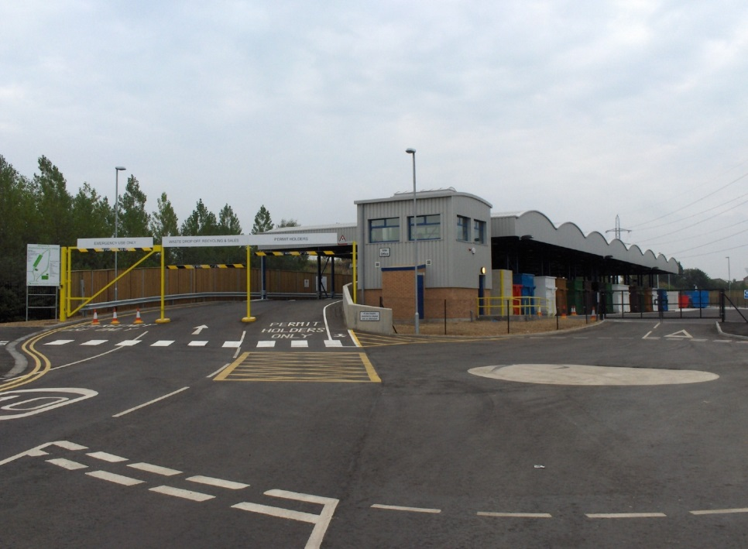

Figure 7‑1: Sealed hardstands present a clean and well-organised facility

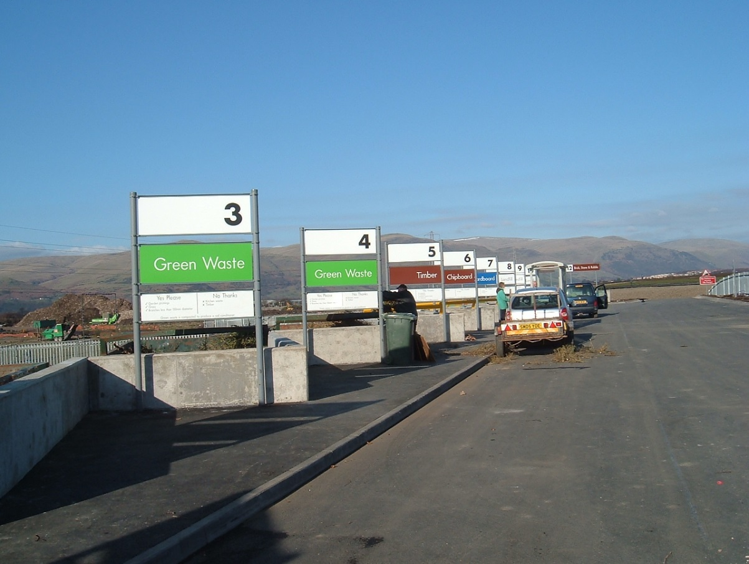

Figure 7‑2: Informative and consistent signage makes disposal simplistic

### Public Place Recycling

The primary use of public bins is waste collection however, their public presence allows for the dual purpose of promotion and education of sustainable waste management. It is best practice for public recycling bins to accept the same materials as is collected in kerbside recycling in order to create cleaner streams and standardise recycling practices.

Public bins can be established permanently throughout the region or temporarily for “special events” such as fetes, festivals and sporting events to manage the generation of public waste. For best results the *EPA Better Practice Guide for Public Place Recycling (2005)* suggests that MGBs are located in clear view at:

* Parks;
* Shopping centres;
* Beaches;
* Walkways and high traffic areas;
* Near entrances and exits to public infrastructure and facilities;
* Near tables / picnic areas;
* Toilet Ablution Blocks; and
* Carparks.

Ideally the public recycling bin would be paired with a residual bin and be accessible from all sides of the bin to limit contamination risks and increase visibility. It is advised that public MGBs are secured, locked or placed within a specialised housing or cabinet. The external housing is beneficial for aesthetics, waste education and security of the MGB.

The most preferred application of Public Place Recycling involves integration across the waste hierarchy with the Waste Education Officer providing education to the public in the importance of their use which can assist in reducing litter within the region.

### On Demand Bulk Kerb/ Verge Collections for Elderly and/or Disabled

Traditionally verge collections are a scheduled service whereby councils provide collections at set time periods throughout the year to all residents. This approach is often abused which results in unsightly piles of waste, subsequent scavenging, collection delays and significant collection costs.

In recent years, on demand services have become increasingly popular amongst councils with residents being allocated a maximum number of verge collections annually. Providing an on-demand service results in a structured composition of waste expelled as residents have placed thought into what waste they will rid of. An on-demand Bulk Kerb/ Verge Collection service for the elderly and/or disabled, can provide those within the community who cannot typically access the local WMF, with a service to remove unwanted recyclables and wastes at any time throughout the year.

As part of the establishment of an on-demand service, MRC would need to consider the creation of guidelines to outline who can participate in the collections and what is classified as acceptable forms of recyclables and waste. Residual waste collection may be restricted in volume whilst recyclables may be unlimited. Typically, there are three options to be considered for material presentation:

* Loose unlimited volume;
* Loose volume limit (often 3m3); and
* Skip bins (often 3m3).

Each option has its own advantages and disadvantages as outlined in **Table 7‑1.**

Table 7‑1: Advantages and disadvantages of forms of verge collection

|  |  |  |
| --- | --- | --- |
| Loose unlimited volume | Loose volume limit (often 3m3) | Skip bins (often 3m3) |
| **Advantages** | | |
| * Convenient as no skip ordering * Convenient for elderly or disabled used as no overhead lifting * Source separation | * Convenient as no skip ordering * Convenient for elderly or disabled used as no overhead lifting * Less safety and environmental concern | * Restricts volume * Suitable recovery at transfer station as waste not compacted |
| ***Disadvantages*** | | |
| * Attracts illegal dumping * Visually unappealing * Safety risk and visual obstruction * Environmental risk * Less room in new high density residential areas | * Visually unappealing * Safety risk and visual obstruction * Less room in new high density residential areas | * Composition not known until transfer station * Little flexibility of collection vehicle type * High capital investment * Increased contamination risk * Council outlay cost for provision of skips, collection, waste sorting |

*Source: Swan Hill Council (WA) Review of Bulk Verge Collection Service, Ordinary Meeting of Council (06/07/16)*

In contrast to bulk verge collections, MRC may like to consider ‘free tipping’ days for residents which can provide a useful annual service requiring less effort to manage and organise and at a lower expense than bulk verge collections.

### E-waste

Australia is one of the largest technology users globally purchasing millions of computers annually thus making e-waste an increasing problem. E-Waste is ideal for recycling due to its large volume limiting space in landfills, inclusion of hazardous materials and availability of recovery of non-renewable resources (tin, nickel, zinc, copper).

National Television and Computer Recycling Scheme is the major E-Waste recycling scheme available. Organisations which recycle E-Waste under this program include:

* TechCollect;
* Drop Zone;
* E-Cycle Solutions; and
* Sims Recycling Solutions.

It is worth MRC utilising these organisations to increase diversion from landfill ultimately saving the MRC costs through the extension of the landfills lifespan.

### Return and Earn

Return and Earn is the container deposit scheme in NSW in which community members receive a 10-cent refund per eligible container deposited at any of the following four types of collection points:

* Reverse vending machines;
* Over the counter collection points;
* Automated depots; and
* Donation stations.

MRC could investigate the establishment of an Automated Depot container collection system if it was determined that this was desired by its residents. This system is capable to receiving more than 500 containers at any given time through mechanical scanning and counting. The Automated Depot would complement the services provided at a modern drop-off centre. Residents would be able to gain access with cars or trailers within operational hours and redeem larger quantities of containers in comparison to Reverse Vending Machines and in a shorter timeframe.

### Clean Materials Recovery Facility (MRF)

A ‘clean’ MRF such as the Echuca MRF in nearby Campaspe Shire Council (Victoria), processes only dry commingled recyclables and separates the materials into recycling streams such as paper, cardboard, metals, plastic and glass ready for market. The MRF separates the contamination into a residue stream which is typically removed off site for disposal. MRFs generally incorporate a range of manual labour picking lines and mechanical separating techniques by a variety of means such as by size, weight, sight, magnetism and floatation.

Any commingled kerbside or public place collected recyclables are taken to the MRF for processing. A large scale regional MRF owned and operated by a group of councils could cater for the MRC and surrounding Councils would reduce the risk associated with reliance on a commercial operator. Processed recyclables could then be bulk hauled to market.

### Dirty MRF

In contrast to a ‘clean’ MRF which processes only dry recyclables, a Dirty MRF is a facility which can accept mixed MSW, C&I and/or C&D wastes and separates the materials into organics, recyclables, inert and residue streams. Similar to a clean MRF, these facilities incorporate a range of separating techniques including separation by material size or weight and magnetic separators. As no source separation is required, which can result in a loss of recyclable and recoverable materials to the refuse stream, a Dirty MRF maximises the quantity of materials presented for recovery. However, the product streams generated contain higher levels of contamination than those generated following source separation. Depending on the outputs of the Dirty MRF, this contamination can have a significant effect on future uses and potential revenue.

Following separation, the organic stream can be processed aerobically and/or anaerobically to generate a compost product and potentially energy. Within Europe, Dirty MRFs are utilised to separate refuse streams of specified calorific values which are then fed into Energy from Waste (EfW) facilities.

## Recover and Treat

### Organics Bin (3rd Kerbside MGB)

The implementation of source separated organics is most commonly undertaken through the utilisation of a targeted kerbside collected MGB which accepts GO (Garden Organics) or FOGO (Food Organics Garden Organics). The primary objective of source separates organics collection is to generate clean streams to divert these materials from landfill and facilitate a greater end use for the organics via composting or similar. In addition, removal of the organics within MSW stream minimises the generation of leachate and methane within landfills. Therefore, benefits of introducing a source separated organics system can be the production of a quality product, minimisation of groundwater contamination from landfill, increased recovery rate, reduction in greenhouse gas emissions and increased landfill life expectancy.

The quality of compost produced in a biological waste process is influenced by the level of contamination of the waste stream. While front end separation of organics from the remainder of the waste stream is possible the final quality of the compost tends to still be affected if the waste stream initially is highly contaminated. Therefore, a separate organics waste collection service is preferred to minimise the level of contamination. This provides higher quality compost that is more marketable and of higher value. Uncontaminated compost of good quality can add significant benefits to soils, reducing the quantities of fertilisers and water used for agriculture or horticulture.

The MRC may be able to generate revenue from the products created from organic waste processing. In particular, MRC could target the large agricultural industry in and surrounding the MRC area.

The NSW EPA supports the notion of a third bin system or organics recycling through its ‘Waste Less Recycle More’ Initiative (2017-2020). The initiative supports the diversion of waste from landfill. With both food and garden organic waste being a large portion of waste entering landfills the segregation of waste streams at residential properties is optimal. By establishing a third bin system within the MRC it is recognised that the source separation:

* Provides higher value waste streams allowing for better resource recovery;
* Reduces contamination of waste streams;
* Diverts materials from landfill;
* Further develops a culture of source separation and recycling in the Community;
* Supports achieving the NSW Landfill Diversion Targets and outcomes; and
* Is consistent with the Waste Hierarchy.

A cost benefit analysis has been undertaken to provide further detailed information regarding the implementation of a 3rd bin and is provided in **Appendix B**.

### Organic Waste Processing

Separated organic waste streams, including food waste and greenwaste, may be processed either aerobically or anaerobically to generate a compost product, which could be used by MRC or sold to local businesses or the community.

Composting is a biological process through which biodegradable material is broken down by naturally occurring micro-organisms in the presence of oxygen (aerobically). Aeration may be achieved by mechanically turning the material, or through forced aeration. When undertaken under correct conditions (such as temperature, moisture and nutrient content, duration and pile size), heat generated during composting can kill both weeds and pathogens within the feedstock material.

#### Forced Aeration and Windrow

Forced aeration (Mobile Aerated Floor (MAF)) systems are often used as a pre-treatment process prior to windrows. MAF systems operate through electrically driven fans which pump air through perforated pipes situated underneath compost piles. The system allows for controlled oxygen release per minute. This slow oxygen release process occurs over an eight week period.

Windrow aeration composting is a simple system, through which material are grinded via tub grinders and left in windrows. To increase airflow and stimulate processing the windrows are turned via excavator (or specialist windrow turners) approximately four times throughout the processing period in order to increase airflow and ensure the biodegradation process continues until compost is produced. Windrow composing may take 90 – 120 days to complete.

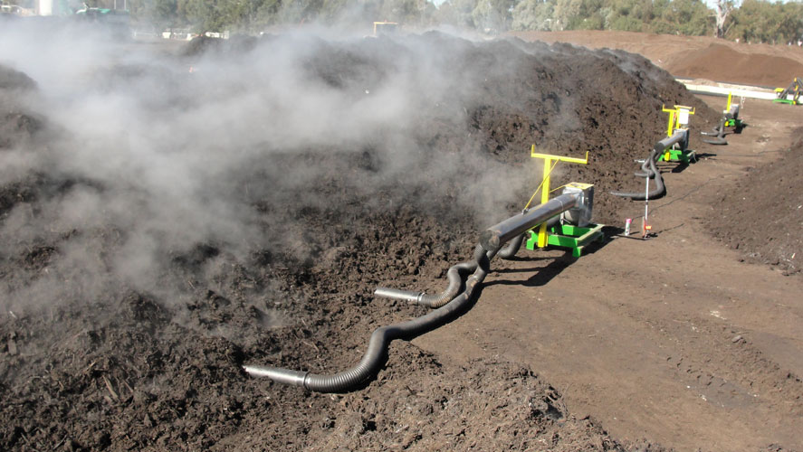

Figure 7‑3: Mobile Aerated Floor composting system

http://www.maf-compostingsystems.de/custom-composts.html

#### Aerated Static Pile

Aerated Static Pile (ASP) uses stationary piping to provide aeration through a blower operating either continually or intermittently. The process is complete in 45-60 days with limited to no turning of the product required. The process is best for homogeneous organic waste and is suitable for FOGO.

#### Anaerobic Digestion

Anaerobic Digestion (AD) technology breaks down the organic (biogenic) component of the waste stream in the absence of oxygen. The result is biogas (that is used to generate electricity), and organic digestate. The solid fraction of the digestate is often used to produce compost while the liquid component can be used as a liquid fertiliser.

Traditional AD facilities that process household waste have consisted of large scale facilities processing 50,000 to 100,000tpa. Recent developments in the market have introduced smaller modular AD systems which can process small volumes of waste. For example, manufactures can supply AD systems with capacities ranging from 50tpa to 40,000tpa which make these systems more viable for rural Councils similar to MRC.

### Thermal Energy from Waste

Thermal waste treatment processes are able to process all wastes except for non-combustible materials such as inert wastes and some forms of hazardous wastes. Thermal processes can be used to recover the energy content of the waste stream to produce electricity, heat or fuel however, they also generate a solid residue which in some cases requires special management. Thermal treatment is able to reduce the volume of waste by up to 95%, thereby significantly reducing the quantity of waste disposed to landfill.

The three main types of thermal waste treatment are outlined in **Table 7‑2**.

Table 7‑2: Types of Thermal Energy from Waste Technologies

|  |  |
| --- | --- |
| Type | Description |
| Gasification | Gasification occurs in a low oxygen environment and involves a long residence time which results in less complex chemicals being generated by the process. This is done through the presence of heat at temperatures of 760°C to 1370 °C without combustion and a controlled amount of oxygen and/or steam. The syngas produced is used as a fuel to generate energy. It is mostly used to generate steam which in turn drives steam turbines to generate electricity. |
| Pyrolysis | Pyrolysis is similar to gasification however, is undertaken in an oxygen free environment and at lower temperatures. Pyrolysis utilises an indirect, external heat source, typically at temperatures of 400°C to 900°C in the absence, or almost complete absence of oxygen, to thermally degrade carbon-based material. Pyrolysis has significantly lower costs for flue gas clean-up than conventional combustion systems which accept specific waste streams as feedstock are able to process as little as 8,000 tpa. |
| Combustion | The combustion of waste materials involves the incomplete burning of waste materials in an oxygen-rich environment to create ash, flue gas and heat. Generally, the process is undertaken at temperatures of 850 °C to 1370 °C. The heat in the flue gas can be captured and used to generate electricity, as an input to an industrial process.  The large amounts of air required to ensure complete combustion of the bulky waste in turn produces large quantities of flue gas. Combined with the combustion process being less controlled than gasification, the large amount of flue gas mean that the flue gas cleaning systems are more complicated and expensive. Therefore, it is anticipated that more than 100,000 tpa of waste is required to ensure the viability of a combustion facility. |

MRC may wish to consider thermal treatment technologies in the future however, due to the low volumes of waste currently generated or received within the MRC, it is unlikely that these type of waste management processes would be suitable in the near to mid-term.

## Dispose

As previously mentioned it is recognised that landfilling is the least preferred method for waste disposal however, following resource recovery it is common that a small portion of residue waste will always require landfilling. All effort must be made to exhaust resource recovery options prior to disposal of waste through landfilling.

Disposal options such as best practice landfills, centralised infrastructure locations, WMF network, transport logistics and consolidation opportunities are identified and evaluated within **Section 9**.

## Data Management

A review of the MRC’s current waste data reporting framework recognises potential areas for improvement including waste classification, data collection methods, technology and reporting systems. Better data management will enable MRC to become more informed and aware of waste streams entering landfills and as a result implement tailored solutions which assist in further reduction of waste to landfill.

### Weighbridges

To record weights of recyclables and waste entering WMFs, the MRC should consider the installation of weighbridges. Weighbridge data collection is currently only undertaken at Moama WMF. The utilisation of a weighbridge enables the accurate recording of waste tonnages entering site and thus the accurate calculation of the cost to disposal. Furthermore, it enables landfill engineers to accurately calculate remaining landfill volume and the remaining life of the landfill. This information is beneficial when planning for future development.

In addition, any future service contracts should look to obtain full records of waste quantities where possible to ensure MRC is aware of any waste entering its sites and is therefore, in a better position to avoid any unknown/uncategorised material being landfilled. To facilitate this approach it is advised that MRC control weighbridges installed at any WMFs.

### Administration and Waste Reporting Framework

Within MRC’s current administration system, there are data gaps regarding the quantities, types and classification of waste accepted at the various waste facilities including the location of public bins. Improving data management, collection and reporting methods will go some way towards addressing these data gaps.

It is recommended that the following data is recorded by the MRC at waste facilities in order to improve data accuracy and enable the MRC to make informed decisions on waste management into the future:

* Type of vehicle entering site;
* Type of waste within vehicle;
* Waste stream (MSW, C&I and C&D);
* Quantity of bins collected by kerbside collection vehicle;
* Quantity of bins missed on collection route by kerbside collection vehicle; and
* Waste volume or weight.

By developing and implementing such a waste reporting framework, MRC would be able to centralise waste data capture and build a comprehensive database of all waste activities. This would ensure MRC is equipped to make more informed waste management decisions which can ultimately support the move towards more sustainable waste management system.

Using this approach MRC can liaise with the waste contractor(s) to ensure accurate waste data collection and reporting.

## Regional Collaboration Options

The implementation of sustainable waste management systems can be complemented through the use of partnerships and in particular can have a significant impact if undertaken on a regional scale. In addition, a regional approach supports the generation of greater economies of scale and therefore may provide the MRC with lower waste management service costs and potentially greater operational efficiencies, while being mutually beneficial to all parties involved.

During the preparation of this document, MRC liaised with neighbouring local governments to discuss any potential waste related opportunities and/or synergies that may exist. In particular MRC sort interest regarding the following collaborative opportunities:

* Joint tendering;
* Regional contracts;
* Shared waste education staff; and/or
* Shared waste infrastructure and/or disposal services.

As a result of the correspondence, the following Councils showed a desire to investigate options for regional collaboration with MRC:

* Campaspe Shire Council;
* Swan Hill Rural City Council;
* Gannawarra Shire Council; and
* Balranald Shire Council.

Due to this level of interest from its neighbouring Councils, it is suggested that MRC consider strategic options which can be undertaken at a regional level and seek input and involvement from the abovementioned Councils. In particular, MRC should at least consider aligning contract periods where possible to assist in facilitating the development of joint contracts for services such as kerbside collections or bulk waste processing.

A regional contract in which the Contractor undertakes kerbside collection and processing (if collecting recyclables) on behalf of other surrounding Councils can reduce costs and minimise the exposure risk to the recycled material commodity market. In addition, by combining both the collection and processing within a kerbside recycling contract, it provides the contractor with greater control over the material and reduces their operational risks related to market and commodity prices. Furthermore, it facilitates the ability for a contractor to offset each cost against the other and also potentially generate greater revenues.

Similar to a joint kerbside collection contract, it is anticipated that a regional Bulk Collection/Processing contract would facilitate economies of scale to obtain a better value for money services. The following bulk services could be considered for Regional Bulk Processing Contracts:

* Greenwaste / Organics processing;
* Scrap Metal collection;
* C&D processing;
* Mattress processing; and
* E-Waste collection.

In addition, MRC should explore opportunities associated with the development of council owned and operated waste management infrastructure. Such items may include clean MRFs and organics processing/composting and can cater for a number of different councils within the region. Utilising economies of scale, regional collaboration between councils can successfully provide long-term services and infrastructure.

## Options Summary

Table 7‑3 provides a summary of the Resource Recovery options.

Table 7‑3: Summary of Resource Recovery Options

|  |  |  |
| --- | --- | --- |
| Resource Recovery | | |
| **Avoid, Reduce, Reuse** | **Recycle** | **Recover and Treat** |
| * Reuse and Tip-Shops * Integrated Community Education and Behavioural Change Programs * Waste Education Officer * Mobile Apps * Commercial Waste Minimisation Practices * Reuse Websites | * Modern Drop-off Centres (Front of House) * Return and Earn * Public Place Recycling * On Demand Bulk Kerb/ Verge Collections * Clean MRF * Dirty MRF | * Organics Bin (3rd Kerbside MGB) * Forced Aeration and Windrow * Mechanical Aeration * Anaerobic Digestion * Thermal Energy from Waste |

Options as outlined in **Table 7‑3** are evaluated in **Section 8** (Resource Recovery options) along with complementary options such as regional collaboration concepts and data management.

# Evaluation of Resource Recovery Options

Resource Recovery options were evaluated through a support structure analysis and furthermore through a Strengths Weaknesses Opportunities Threats (SWOT) analysis to determine the most preferred.

## Support Structures

The implementation of Resource Recovery Options requires supporting structures to be successful. Having these support structures in place is often greatly beneficial to the implementation of Options, and in many cases are essential to their success, particularly for large scale resource recovery initiatives. Support structures utilised in evaluation of Resource Recovery Options and a simple description of each is provided in **Table 8‑1**.

Table 8‑1: Support Structure Overview

| Support Structures | |
| --- | --- |
| Government Legislation and Policy | |
| Waste Levy | * Requirement of the POEO Act, 2014, licenced waste facilities in NSW levy paying areas required to pay a Waste Levy; * Fee aims to reduce waste to landfills though promoting recycling and resource recovery; and * See EPA: Waste Levy Guidelines for further information. |
| Diversion Targets | See Section 6.3 for diversion targets and MRC performance in relation to such targets. |
| Emissions Reduction fund | * AWT and Landfill Gas Capture earn ACCUs as part of EMF; * Aids in generating revenue; * May increase viability of facility. |
| Material Volumes | |
| * Many of the Resource Recovery Options require minimum and consistent quantities of waste material to be generated to ensure that the process is cost effective; and * As the towns within the MRC are relatively isolated from one another, it is often difficult to obtain quantities of materials from other sources. Therefore, it is important that Resource Recovery Options are assessed based on the quantities generated within a practical distance. | |
| Financial mechanisms | |
| * High capital cost common barrier for implementation; * Particularly applies for the establishment of large treatment facilities inclusive of dirty MRFs and AWT; * MRC is largely geographically isolated which increases capital and operational costs; and * Low cost of landfill means that Resource Recovery Options are often not cost effective when compared to direct disposal to land. | |
| * Markets for end products | |
| * Consider availability and profitability of end market for produced product. Products may include compost, Recycled Building Products (aggregates, road base, clean fill etc.), separated packaging materials, energy sources such as electricity and heat. | |
| * Siting requirements | |
| * WMF infrastructure is restricted by certain siting requirements for the deposit of materials and development of infrastructure if required. Certain initiatives require set guidelines as outlined by the NSW EPA, for guidelines on landfills see EPA: Solid Waste to Landfill Guidelines or alternative sources of WTSs. | |
| Infrastructure and service requirements | |
| The Resource Recovery Options presented in Section 7 have a range of infrastructural and service requirements including:   * Infrastructure:   + Suitable site and available footprint;   + Buildings, hardstands, road networks;   + Equipment and machinery; * Services:   + Power; and   + Water. * Many of the options at the top of the Waste Management Hierarchy require little or no additional infrastructure or services. Options for recycling, recovery and treatment of waste materials mostly have infrastructure and services requirements, in particular the thermal EfW processes. The cost associated with potential infrastructure and service requirements may be a significant barrier to the implementation of some of the Resource Recovery Options. | |
| Community support | |
| * Community support is important and may be critical to the successful implementation and performance of the option; * Important to Resource Recovery Options that are potentially more controversial such as large scale waste treatment infrastructure. | |
| Regional Approach | |
| * Supports greater economies of scale; * Enables MRC the ability to cater and process larger quantities of waste; * The costs associated with both constructing and operating WMFs are shared as the operational capacity increases. The average cost per tonne to process the waste is reduced; and * A regional approach presents an opportunity to provide best practice services to residents that may not otherwise have been possible, thereby resulting in social and environmental benefits. | |

Talis has evaluated each of the Resource Recovery Options according to the support structure requirements described within this section. For each Resource Recovery Option, the support structures have been defined as:

|  |  |
| --- | --- |
|  | Not Applicable; |
|  | Beneficial; |
|  | Critical; and |
|  | Limited / Lacking in the MRC. |

The results of this evaluation are shown in **Table 8‑2.**

Table 8‑2: Evaluation of Resource Recovery Options

|  |  |  |  |  |  |  |  |  |  |
| --- | --- | --- | --- | --- | --- | --- | --- | --- | --- |
| **Hierarchy Grouping** | **Strategic Options** | **Legislation and Policy** | **Material Volumes** | **Financial Mechanisms** | **Markets** | **Siting Requirements** | **Infrastructure and Services** | **Community Support** | **Regional Approach** |
| **Avoid, Reduce, Reuse** | Reuse and Tip-Shops |  |  |  |  |  |  |  |  |
| Integrated Community Education and Behavioural Change Programs |  |  |  |  |  |  |  |  |
| Commercial Waste Minimisation Practices |  |  |  |  |  |  |  |  |
| Waste Education Officer |  |  |  |  |  |  |  |  |
| Mobile Apps |  |  |  |  |  |  |  |  |
| Free Trade Websites |  |  |  |  |  |  |  |  |
| **Recycle** | Modern Drop-off Centres (Front of House) |  |  |  |  |  |  |  |  |
| Return and Earn |  |  |  |  |  |  |  |  |
| Public Place Recycling |  |  |  |  |  |  |  |  |
| On Demand Bulk Kerb/ Verge Collections for Elderly and Disabled |  |  |  |  |  |  |  |  |
| Clean MRF |  |  |  |  |  |  |  |  |
| Dirty MRF |  |  |  |  |  |  |  |  |
| **Recover and Treat** | Organics Bin (Third Kerbside MGB) |  |  |  |  |  |  |  |  |
| Forced Aeration and Windrow |  |  |  |  |  |  |  |  |
| Aerated Static Pile |  |  |  |  |  |  |  |  |
| Anaerobic Digestion |  |  |  |  |  |  |  |  |
| Gasification |  |  |  |  |  |  |  |  |
| Pyrolysis |  |  |  |  |  |  |  |  |
| Combustion |  |  |  |  |  |  |  |  |
| **Data Management** | Weighbridges |  |  |  |  |  |  |  |  |
| Administration and Reporting Framework |  |  |  |  |  |  |  |  |
| **Regional Collaboration Options** | Joint Kerbside Collection Contract |  |  |  |  |  |  |  |  |
| Regional Bulk Collection/Processing Contracts |  |  |  |  |  |  |  |  |

It can be seen from **Table 8‑2** that strategic options within the Avoid, Reduce and Reuse segment of the waste hierarchy are heavily reliant on community support to guarantee the success of the option. Overall the upper segment of the waste hierarchy would benefit from legislative support and financial mechanisms but is not dependent on end markets or physical structural requirements. However, reuse options in particular are reliant on markets, siting and infrastructure to develop reuse and tip shops.

Recycling strategic options benefit from material volumes and end markets of the recycled product far more than the upper level of the waste hierarchy. Clean Materials Recovery Facility (MRF) and Dirty MRF require the most critical support across all gages. Both strategic options are lacking financial mechanisms within the MRC and thus are deemed unfeasible options at this point unless established under a regional agreement with neighbouring councils where economies of scale are achieved.

Recover and Treat strategic options require far more critical support overall partly due to spatial and infrastructure requirements, the provision for end markets and regional support to subsidise the high associated costs. Conversely to the upper levels of the waste hierarchy, recover and treat require less community support as there is less direct community interaction. However, community support is still beneficial to ensure clean waste streams in prior stages of the waste hierarchy to increase the efficiency of recover and treat options. Strategic options such as Aerated Static Pile, and thermal AWT are heavily dependent on financial mechanisms and material volumes thus at this point in time these options are impractical for the MRC.

Strategic options associated with Data Management are supported through legislative policy. Weighbridges require critical support for siting and infrastructure and are further beneficially supported by material volumes and the financial means to purchase the weighbridge.

Material Volumes and Financial Mechanisms played a significant role in considering the viability of strategic options for MRC to undertake. As a result, the following were not considered for further analysis:

* Clean MRF;
* Dirty MRF;
* Aerated Static Pile;
* Thermal Energy from Waste:
  + Gasification;
  + Pyrolysis; and
  + Combustion.

It should be noted however, that involvement in the establishment of this type of infrastructure is possible at a regional level. MRC should maintain open dialogue with neighbouring councils and explore opportunities for regional collaboration with an emphasis on processing commingled recyclables and/or organics in the future.

## SWOT Analysis

A SWOT (Strengths, Weaknesses, Opportunities and Threats) analysis was undertaken to evaluate the remaining resource recovery options following the assessment of support structures. It is utilised as a tool to enable the MRC to establish themselves firmly within waste management. The process identifies the internal strengths and weaknesses and external opportunities and threats.

### Avoid, Reduce, Reuse

A summary of the SWOT analysis undertaken for the Avoid Reduce Reuse options within the waste hierarchy are provided in **Table 8‑3**.

Table 8‑3: SWOT Avoid, Reduce, Reuse

| Avoid, Reduce, Reuse | | | | |
| --- | --- | --- | --- | --- |
|  | **Strengths** | **Weakness** | **Opportunity** | **Threats** |
| **Reuse and Tip-Shops** | Generate revenue  Low cost.  Simple operation. | Capital and operational cost.  Maintaining suitable standard. | Cooperation of local community and businesses.  Employment opportunities.  Funding available. | Impact charities and organisations.  WHS. |
| **Integrated Community Education and Behavioural Change Programs** | Improved waste management services. | Capital and operational cost.  Doesn’t engage whole community. | Cooperation of local community and businesses.  Influence consumer behaviour. | Lack of community support.  Misinformation and conflict from others. |
| **Waste Education Officer** | Targets large portion of waste.  Limits problematic waste to landfill.  Increase waste minimisation awareness. | Capital and operational cost. | Cooperation of local community and businesses.  Influence consumer behaviour. Community support for larger waste initiatives. | Lack of community support.  Misinformation and conflict from others. |
| **Commercial Waste Minimisation Practices** | Involves local businesses. | Capital and operational cost.  Buy in from industry sectors. | Cooperation of local community and businesses.  Influence consumer behaviour. | Impact charities and organisations. |
| **Mobile Apps** | Low cost.  Modular.  Advance culture.  Simple operation. | Doesn’t engage whole community. | Community engagement.  Free service to community. | Lack of community support.  Lack of market. |
| **Free Trade Websites** | Low cost;  Targets large portion of waste stream.  Simple operation. | Similar existing system. | Cooperation of local community and businesses.  Community engagement. | Lack of community support.  Impact charities and organisations. |

As seen in **Table 8‑3** Reuse & Tip shops and Free Trade Websites had clear strengths and opportunities, achieving similar results overall. However, Reuse & Tip Shops have an added strength in comparison of Free Trade Websites as they are able to generate revenue for MRC directly. Likewise, the Waste Education Officer had a large number of strengths as there is large opportunity for the Waste Education Officer to educate the public and increase waste minimisation awareness. However, the Waste Education Officer faces the threat of conflicting or misinformation being portrayed to the public by alternative sources.

### Recycle

A summary of the SWOT analysis results for the recycling options are provided in **Table 8‑4**.

Table 8‑4: SWOT Recycle

| Recycle | | | | |
| --- | --- | --- | --- | --- |
|  | **Strengths** | **Weakness** | **Opportunity** | **Threats** |
| **Modern Drop-off Centres (Front of House)** | Improved waste management services.  Advances culture of waste minimisation.  Promotes preferred levels of waste hierarchy.  Limits public interaction with waste operations. | Capital and operational costs.  Similar existing systems.  Maintaining suitable standard.  Large space required. | Cooperation of local community and businesses.  Community engagement.  Influence consumer behaviour.  Employment opportunities | Regularity of market restrictions.  WHS. |
| **Public Place Recycling** | Improved waste management services.  Low cost.  Promotes preferred levels of waste hierarchy.  Simple operation. | Unable to achieve full community engagement.  Contamination. | Cooperation of local community and businesses.  Community engagement.  Influence consumer behaviour.  Free service. | Lack of community support.  Disruption due to contamination.  Fails to service all regions. |
| **On Demand Bulk Kerb/ Verge Collections for Elderly and Disabled** | Improved waste management services.  Low cost.  Advances culture of waste minimisation.  Simple operation. | Visually unappealing.  Unable to achieve full community engagement. | Community engagement.  Influences consumer behaviour.  Free service. | Distribution of process due to contamination.  WHS. |
| **Return and Earn** | Improved waste management services.  Low cost.  Advances culture of waste minimisation.  Consistent.  Limits public interaction with waste operation. | Capital and operational costs.  Similar existing system.  Diversion of material from recycling.  Unable to achieve full community engagement. | Generates revenue.  Cooperation of local community and businesses.  Community engagement.  Influences consumer behaviour. | Market restrictions.  Conflict from other sources.  Distribution of process due to contamination.  Impacts charities. |

In the recycling sector On Demand Bulk Kerb/Verge Collections for Elderly and Disabled proved to have a large number of strengths with minimal weaknesses in the SWOT analysis. The concept promotes waste management of the preferred, higher levels of the waste hierarchy. The concept is heavily reliant on community engagement and influences consumer behaviour. However, the service is only suggested to be provided to the elderly and/or disabled, thus the service is unable to achieve full community engagement or target a large portion of the waste stream. Further to On Demand Bulk Kerb/Verge Collection for Elderly and Disabled, Modern Drop-off Centres performed well. The Centres provide an opportunity for MRC to generate revenue whilst increasing community engagement and promotion of waste minimisation. Although a strength of the Centres is their ability to capture a large segment of the waste stream their weakness lies in being the most expensive recycling strategic option. Public Place Recycling should be considered by the MRC however it is susceptible to contamination by community members and requires large community support to be a viable option. Integration with the Waste Education Officer is required increase its efficiency of implementation. On Demand Bulk Kerb/Verge Collections for Elderly and Disabled and Modern Drop-off Centres were the preferred recycling options in the SWOT analysis.

### Recover and Treat

A summary of the SWOT analysis undertaken for the recycling level of the hierarchy is provided in **Table 8‑5.**

Table 8‑5: SWOT Recover and Treat

| Recover and Treat | | | | |
| --- | --- | --- | --- | --- |
|  | **Strengths** | **Weakness** | **Opportunity** | **Threats** |
| **Organics Bin (Third Kerbside MGB)** | Improved used of waste management services.  Low cost.  Diversion of organics from landfill.  Targets large portion.  Reduced greenhouse emissions. | Capital costs.  Maintaining suitable standard.  Unable to achieve full community engagement.  Contamination. | Community engagement.  Influence consumer behaviour.  Engage agricultural sector.  Funding opportunity. | Lack of community support.  Fails to service all regions. |
| **Forced Aeration and Windrow** | Low cost.  Modular.  Targets large portion of waste.  End markets.  Simplicity. | Maintaining suitable standard.  Contamination.  Large space requirements.  Odour. | Generates revenue.  Engage agricultural sector.  Improve soils. | Regulatory or market restrictions.  Environmental approval.  Contamination. |
| **Anaerobic Digestion** | Modular.  Electricity generation.  Simple operation.  Reliable long term project. | Cost.  Operational complexity.  Contamination.  Large space requirements.  Odour. | Integration to other strategic options.  Engage agricultural sector. | Regulatory or market restrictions.  Difficulty obtaining environmental approval.  Contamination.  Environmental impacts. |

As seen in **Table 8‑5** the option of an Organics Bin (3rd kerbside MGB) appears to have a high quantity of strengths and opportunities. The concept targets a large portion of the waste stream but requires education from the Waste Education Officer to aid in minimising the threat of contamination and maintaining a suitable standard for processing. Through this integration of the waste hierarchy it enables the organic waste processing to further increase its strength of revenue, increasing its profitability. Forced Aeration and Windrow was the preferred organic waste processing to compliment the introduction of an organics bin (3rd kerbside MGB). The process is faster, requires less space, lower minimal quantity and is less cost invasive than alternative organics processing. Although Forced Aeration and Windrow processing is able to be profitable there lies a threat in lack of markets or market restrictions. If MRC seeks to implement a composting process themselves it would be likely undertaken at the Moama WMF with product being sold to the agricultural sector and community. Of the Recover and Treat level of the waste hierarchy, the establishment of an Organics Bin (3rd kerbside MGB) and the complementary process of Forced Aeration and Windrow was the preferred strategic options.

A further analysis of potential third bin options (GO and FOGO) and corresponding treatment processes are further analysed in **Appendix A.**

### Data Management

A SWOT analysis was undertaken for the data management options and is provided in **Table 8‑6**.

Table 8‑6: SWOT Data Management

| Data Management Options | | | | |
| --- | --- | --- | --- | --- |
|  | **Strengths** | **Weakness** | **Opportunity** | **Threats** |
| **Weighbridges** | Accurate data collection.  Prevents disputes related to fees & charges. | Capital cost.  Staff training required.  Maintenance and upkeep. | Know the waste types and quantities accepted at WMFs.  Reporting made simpler. | Over cater for site needs.  Calibration issues.  Misuse or non-use (by Contractor). |
| **Administration and Waste Reporting Framework** | Generates more information.  Facilitates greater data interrogation.  Accurate data management. | More time consuming.  Training required to interrogate data. | Employment opportunities.  Justify new project expenditure on sound evidence. | Data collected but not utilised. |

From **Table 8‑6** it can be seen that more accurate data management can assist the operation of WMFs and delivery of services. A weighbridge is a small capital cost compared to its useful life and can simplify the challenging task of volumetric estimations and provide significantly more accurate data. This data in turn facilitates detailed interrogation which can support the delivery of new projects based on the justifiable evidence.

It is suggested that MRC assess current waste data gathering and reporting framework to ensure that the weight/volume, sources and generators of waste are recorded.

### Regional Collaboration Options

**Table 8‑7** shows the results of the SWOT analysis for the Regional Collaboration Options.

Table 8‑7: SWOT Regional Collaboration Option

| Regional Collaboration Options | | | | |
| --- | --- | --- | --- | --- |
|  | **Strengths** | **Weakness** | **Opportunity** | **Threats** |
| **Joint Kerbside Collection Contract** | Improved waste management services.  Low cost.  Targets large portion of waste.  Consistent approach. | Similar existing system.  Operational complexity.  Maintaining suitable standard. | Integration with other strategic options. | Market restrictions. |
| **Regional Bulk Collection/ Processing Contracts** | Low cost  Targets large portion of waste.  Regional approach.  Reliable.  Limits problematic waste to landfill. | Capital and operational costs.  Similar existing systems.  Operational complexity. | Generates revenue.  Integration with other strategic options. | Regularity of market restrictions. |

Both regional collection contracts have similar strengths of being low cost and targeting a large portion of waste. The overarching collection contracts are of greater operational complexity than collection contracts currently operated by MRC. A regional bulk collection contract is preferable as it is able to generate revenue and limit problematic waste from landfill.

## Preferred Resource Recovery Options

It is appreciated that MRC are providing a comprehensive waste management service to its residents however, based on the support structure evaluation and SWOT analysis the following preferred Resource Recovery Options have been identified to improve the effectiveness and efficiencies of the overall waste management system:

* Avoid Reduce Reuse:
  + Reuse & Tip shops;
  + Free Trade Websites;
  + Waste Education Officer;
* Recycle:
  + On Demand Bulk Kerb/Verge Collections for Elderly and Disabled;
  + Modern Drop-off Centres;
  + Public Place Recycling;
* Recover and Treat:
  + Organics Bin (3rd kerbside MGB);
  + Forced Aeration and Windrow;
* Data Management:
  + Assess current waste data gathering and reporting framework to ensure that the weight/volume, sources and generators of waste are recorded.
* Regional Collaboration:
  + Joint Kerbside Collection Contract; and
  + Regional Bulk Collection/ Processing Contracts.

# Disposal Options

Determining the best long-term waste disposal services for the MRC is a key objective of the waste management strategy, to ensure that all materials that cannot be avoided, reused, recycled or recovered are disposed of accordingly. Currently, the predominant management option for the majority of waste generated within the MRC is disposal, with four landfills currently operating across its jurisdiction. As previously outlined, landfilling is the least preferred approach in accordance with the waste hierarchy. However, even the highest performing waste management systems across the world have a reliance, although small, for best practice landfill disposal.

In addition, it is important that this strategy identifies current disposal systems and assess a variety of feasible long-term options to ensure that MRC can make an informed decision to determine the most efficient and sustainable options moving forward. The following sections outline the works undertaken as part of the assessment and associated key findings.

## Waste Disposal Scenarios

It is recognised that the total void space remaining at each of the four landfills varies significantly and is dependent on the catchment areas and corresponding waste intake. Moama has the largest land area available but also accepts the most waste (16,049 tpa). However, the greater quantities of waste accepted at the site does not significantly influence its landfill life due to the future expansion areas available to the north of the site. It is anticipated that even with the ongoing acceptance of the C&I waste stream, Moama will continue to remain open for 40+ years. Approvals have been granted for MRC to extend the landfill into the adjacent land to the north, securing its long-term future.

If regulatory drivers where to force the closure of the other landfills, as a worst-case scenario it is possible that Moama could accept all the waste from across the MRC region for an extended period of time due to the significant remaining landfill void space and the relatively small quantities generated outside of the Moama area. This supports the notion that Moama should continue as MRC’s main landfill into the future. Therefore, as Scenario 1, Talis has assessed the Moama WMF as the sole landfill across the MRC and all waste materials transferred to the site.

The Koraleigh WMF is the next most noteworthy landfill after Moama however, it accepts a significantly less quantity of annual waste at 2,753 tpa. Following a site visit, it was recognised that it has substantial remaining landfill void space based on the anticipated annual tonnage into the future including the acceptance of C&I waste. Koraleigh has been operated by a contractor recently and has been developed into a significant piece of waste management infrastructure which MRC can utilise into the future. Based on Koraleigh’s location in the far west of the MRC region, it is positioned well to capture the waste generated in this area, reducing the requirement for significant transportation of waste and relieving part of the reliance on Moama. The current landfill is not in a suitable state to undertaken closure and rehabilitation works, to minimise the long-term liabilities associated with the facility. The MRC should continue to accept waste to fill the landfill into a suitable closure and capping profile. As Scenario 2, Talis has assessed the financial and technical aspects of operating Koraleigh and Moama as the two landfill sites in the MRC.

Wakool and Moulamein WMFs are smaller than both Moama and Koraleigh accepting approximately 124 and 93 tpa respectively. Both these sites do not present significant long-term opportunities for landfilling based on their size, small catchments, distance from the larger volumes of waste and significant costs in hauling waste to these destinations. The continued operation of these facilities as landfills will result in MRC bearing long term operational and capital cost over low tonnages and corresponding environmental liabilities for very small facilities. Therefore, in order to maintain services near the communities of Moulamein and Wakool while also increasing the overall landfilling standards in the MRC, limiting council environmental liabilities and saving on long-term operational and capital costs, it is suggested that both Moulamein and Wakool Landfills be re-established as modern community drop-off centres which act like small scale WTSs. Through this approach waste can be accepted at these sites and transferred to properly engineered and operated landfills at either Moama or Koraleigh. However, for completeness in assessing long term disposal options, Scenario 3 includes Wakool as the third landfill operating within the MRC complementing Moama and Koraleigh. Wakool was not selected for any particular reason over Moulamein, it is only to demonstrate the effects of a third facility on the modelling operating within the middle of the MRC.

In addition, it was discovered following site visits to each facility, that there were two sites which are located in close proximity to larger more well operated facilities and should therefore be closed completely due to an oversupply of services. The small unmanned facility at Womboota and the small operating landfill at Goodnight should both be closed permanently to minimise long-term environmental liabilities, reduce operational costs and provide an efficient waste management service. The closure of both these sites was modelled within each Scenario.

Therefore, the abovementioned waste disposal Scenarios were developed for further assessment to determine the most preferred for MRC and are outlined in **Table 9‑1**.

Table 9‑1: Waste Disposal Scenarios

|  |  |  |  |  |  |  |  |  |  |  |  |  |  |
| --- | --- | --- | --- | --- | --- | --- | --- | --- | --- | --- | --- | --- | --- |
| Scenarios | Name | Landfills | | | Community Drop-Off Centres | | | | | | | Close Facility | |
|  |  | **Koraleigh** | **Moulamein / Wakool** | **Moama** | | **Koraleigh** | **Moulamein** | **Wakool** | **Barham** | **Bunnaloo** | **Mathoura** | **Goodnight** | **Womboota** |
| **1** | **Moama Landfill** |  |  | ✓ | | ✓ | ✓ | ✓ | ✓ | ✓ | ✓ | ✓ | ✓ |
| **2** | **Moama & Koraleigh Landfill** | ✓ |  | ✓ | |  | ✓ | ✓ | ✓ | ✓ | ✓ | ✓ | ✓ |
| **3** | **Moama, Koraleigh and Wakool as Landfills** | ✓ | ✓ | ✓ | |  | ✓ |  | ✓ | ✓ | ✓ | ✓ | ✓ |

## Design Input

In devising the Scenarios to satisfy the long-term waste disposal requirements for MRC, the utilisation of the existing WMF infrastructure and required capital works to these existing facilities, was proposed. This was essential in order to ensure that a suite of comprehensive Scenarios were identified and could be fully assessed. The following sections outline the key design inputs into the modelling works.

### Best Practice Landfill

The EPA’s Solid Waste to Landfill Guidelines (2016) provides guidance and the standards for landfills in order to be classified as best practice in NSW. MRC should seek to improve its waste disposal infrastructure by transitioning to best practice design and operations. This reduces the potential for long-term environmental impacts and liabilities associated with landfilling. The key element of best practice landfills includes composite basal lining systems along with leachate, surface water and landfill gas management systems.

Moama Landfill has been designed and is operated to the highest standard amongst all MRC landfills. The landfill has significant void space available for long term disposal and there are plans to expand the site for future disposal. The site is also well placed to be a major regional landfill for the area. Continuing to improve and transition Moama Landfill into a best practice landfill, ensures MRC retains and secures long term waste disposal infrastructure.

It is unlikely that other existing sites will require development to a best practice landfill standard in the short to medium term. There are definitely improvements required to each of the additional landfill sites however, it is anticipated that only one other landfill would be required to complement the best practice landfill at Moama and to cater for the waste generated in the western areas of the MRC region.

### Landfill Closure

It is proposed that a number of MRC’s landfills should be closed in order to reduce operational and environmental liabilities now and into the future. However, it is irresponsible to simply walk away from an existing landfill site without:

* Adequately preventing the escape of waste for constructing a capping layer;
* Minimising the production of leachate, odour and landfill gas;
* Ensuring surface water is shed from the capping surface;
* Ensuring the site is stabilised; and
* Establishing security fencing to prevent unauthorised access to the closed landfill.

The establishment of a landfill cap will ensure that MRC’s long-term landfill liabilities are reduced following the closure of sites. In addition, it was assumed that a 10m maximum closure height of the landfill was allowable and that all material required to close the landfill was available onsite. Furthermore, without preparing designs for each site, a simple rectangular (best fit) closure profile was conceptualised to calculate indicative closure cost calculations. The cost estimates focused on understanding what capital expenditure is required for the MRC to close a landfill site in its current state and subsequently converting them into modern community drop-off centres (small WTSs).

### Modern Community Drop-Off Centres (Small WTS)

A modern community drop-off centre provides the community with clean and well-organised waste and recycling drop-off services. The layout supports the waste management hierarchy but remains simplistic and clearly signposted. Reuse shops are located at the front of the site followed by recycling areas. Lastly any residual waste can be disposed of at the raised split level (saw-tooth design) into hook lift bins. The hook lift bins are then transported to a landfill for disposal.

For the purpose of this study, the design of the waste disposal area of the modern community drop-off centres, included:

* Three hook-lift bin bays arranged in a saw-tooth configuration;
* A split-level height of 1.6m; and
* 30m3 hook lift bins.

This design minimised the capital expenditure while providing substantial bin capacity across the three hook lift bins and additional flexibility to accept alternate materials if desired.

### Logistics Modelling

Kerbside general waste collections were modelled in order to determine the associated costs to transport waste to the nearest available landfill in accordance with each scenario. Modelling was based on a 9 tonne kerbside collection vehicle operating at a rate of $120/hour.

In addition, transportation of waste utilising hook-lift bins from the modern community drop-off centres was assessed for each scenario that included a waste transfer component. This approach involves the consolidation of waste requiring landfilling. Once consolidated in the hook-lift bins, these materials are then carted away to landfill. This is referred to as small scale bulk haulage and results in an average compaction rate of 0.3 tonnes per m3, equating to approximately 10 tonnes per load using hook lift bins of 30m3 capacity.

Transport costs were calculated utilising the following information as inputs in conjunction with the distances between each facility according to the scenario:

* Size of hook-lift bin (m3);
* Transport Price ($/trip);
* Transport time (hrs);
* Price per hour;
* Loading Time (hrs);
* Unloading Time (hrs);
* Average Speed (km/hr); and
* Distance (km).

## Financial Assessment

To understand the financial implications of the various scenarios, a financial model was prepared to provide an indication of the costs over a 10 year period. However, due to the varying quantity and quality of the available information specific to each site, the financial modelling was based on the best available information, Talis’ own capital and operational cost estimates and a suite of assumptions. In particular, the proposed developments at each site were based on a conceptualised approach. This was done to identify suitable options that warrant further consideration by the MRC and to identify the cost difference between the proposed scenarios.

The capital costs for the sites represent all expenses associated with the establishment of physical infrastructure such as earthworks, road works, buildings, equipment, surface water management and the materials required for restoration to close the landfill. The purchase of the equipment and machinery has been categorised as capital items. The operational cost estimates were generated utilising a range of datasets including operational budgets, previous projects undertaken by Talis and general industry knowledge/experience. This included obtaining costs for:

* Labour;
* Consumables;
* Machinery and Vehicle amortisation;
* Utility Services; and
* Additional operating expenditure.

Talis has undertaken cost per tonne modelling based on the tonnages to be accepted in the MRC and the capital and operational expenditure which will be incurred. The modelling determines the break-even cost per tonne over the 10 year period. It should be noted that the financial model does not include the revenue generated at any of the waste management facilities. This approach demonstrates the indicative costs to MRC for each scenario and assists to identify those options that warrant further detailed consideration.

### Financial Assumptions

In order to complete the financial assessment, a number of assumptions were made with some of the key ones listed below:

* Bulk haulage hook-lift vehicles were modelled at a capacity of 30m3;
* Transport costs were modelled based on previously known contractor rates for hook-lift vehicle and kerbside collection movements;
* Kerbside collection vehicles were modelled with a capacity of 9 tonnes and an average speed of 50km/hr;
* Kerbside collection lift rate per bin was not included as the contracted number of bins and rate would not change under any scenario;
* Cell lining for Moama comprised of clay and not Geosynthetic or Geomembrane lining systems;
* Landfill capacity for a landfill was calculated at a maximum height of 8m above ground level;
* Based on the current anticipated waste tonnages generated within the MRC, 215,557 tonnes was calculated as the total landfilled over the next 10 year period;
* Rates included provision for Local loading (5%) for comparison to Melbourne prices, Contingency (10%) and professional services (8%);
* Capital costs have been amortised over the expected life of each asset, using a discount rate of 5% per annum. The annual amortised cost of all equipment associated with a Scenario have been included in the annual Operational Costs of the Scenario; and
* Costs are based on current day costs with 2.5% inflation rate applied to any future costs over the modelled 10 year period.

It must be noted that these costs are indicative only and further investigation, detailed feasibility and concept design work would be required for future planning and budgeting purposes.

### Scenario 1 – Moama Only Landfill

Scenario 1 (**Table 9‑2**) utilises Moama as a single operating landfill within MRC and the conversion of other landfills into community drop-off centres. In addition, Barham, Bunnaloo and Mathoura continue operation while it is proposed that Goodnight and Womboota are closed.

Table 9‑2: Scenario 1 – Moama Only Landfill

|  |  |  |  |  |  |  |  |  |  |  |  |  |  |
| --- | --- | --- | --- | --- | --- | --- | --- | --- | --- | --- | --- | --- | --- |
| Scenario | Name | Landfills | | | Community Drop-Off Centres | | | | | | | Close Facility | |
|  |  | **Koraleigh** | **Moulamein / Wakool** | **Moama** | | **Koraleigh** | **Moulamein** | **Wakool** | **Barham** | **Bunnaloo** | **Mathoura** | **Goodnight** | **Womboota** |
| **1** | **Moama Landfill** |  |  | ✓ | | ✓ | ✓ | ✓ | ✓ | ✓ | ✓ | ✓ | ✓ |

The total cost for Scenario 1 is a combination of capital, operational and transport costs spread over a 10 year lifetime as evidenced through the range of facilities being utilised under this scenario.

#### Capital Costs

**Table 9‑3** shows the costs to continue operation at Moama landfill for the next 10 years. The costs included capital costs to build clay lined cells (not geosynthetic or geomembrane lined) and capping.

Table 9‑3: Scenario 1 10 year Capital Costs for Moama Landfill

|  |  |
| --- | --- |
| Base Earthworks | Cost |
| Basal Lining System | $4,824,724 |
| Leachate Extraction and Evaporation Pond | $31,214 |
| Restoration and Capping Layer | $1,741,205 |
| Miscellaneous | $437,313 |
| Infrastructure | $245,000 |
| Equipment | $348,562 |
| Sub Total | $7,628,018 |
| Local Loading (5%) | $381,401 |
| Professional Services (8%) | $610,241 |
| Contingency (10%) | $762,802 |
| **Total** | **$9,382,463** |

It can be seen from **Table 9‑3** that the capital cost at Moama is $9,382,463 over the next 10 years. This is to be expected as Moama is MRC’s main landfill and receives significantly more waste than the other sites and therefore, is continually building and constructing landfill cells while closing and capping previous cells. In addition, it is licenced and is therefore subject to stricter environmental controls.

In contrast, Scenario 1 ceases landfill operations at Koraleigh, Moulamein and Wakool which means that before they can be utilised as a modern community drop-off centre, each landfill site needs to be suitably capped. This approach would require a capping layer, comprised of the materials described in **Section 9.2.2**, to be constructed to prevent water ingress into the waste mass. The capital costs to undertake this exercise are shown in **Table 9‑4**.

Table 9‑4: Scenario 1 Short-term Landfill Closure Costs

|  |  |  |  |
| --- | --- | --- | --- |
|  | **Koraleigh** | **Wakool** | **Moulamein** |
| **Total Cost** | **$432,457** | **$266,890** | **$205,953** |

From **Table 9‑4** it can be seen that Moulamein has the lowest capital cost due to its smaller size. Similarly, Wakool has a lower capital than Koraleigh which is apparent due to the smaller land area of the Wakool site therefore, requiring less capping material to close in its current state.

If under this scenario Koraleigh, Moulamein or Wakool were closed as landfills but were to remain open accepting waste and recyclables from the public, then it is suggested that each would be converted from a landfill into a modern community drop-off centre. To provide an indication of the capital cost to construct a facility which utilises a split-level saw-tooth arrangement with multiple hook lift bins, **Table 9‑5** has been provided.

Table 9‑5: Community drop-off centre capital cost

|  |  |  |
| --- | --- | --- |
| **No. of Hook Lift Bins** | **Height of Bays** | **Cost** |
| 3 | 2.6 | **$ 249,666** |
| 3 | 1.6 | **$ 204,175** |

It can be seen from **Table 9‑5** that capital costs have been provided for a 3 bay split-level system for a 1.6m tall saw-tooth retaining wall for 3 bays will cost approximately $205,000. Raise this to the full height of the hook-lift bin (2.6m) and an additional $50,000 is added the cost. If a roof was to be placed over the top of the unloading and bin areas, the capital cost is approximately doubled. For the purpose of this assessment, the least costly capital investment ($204,175 per site) has been applied to each of the three converted facilities.

#### Operational Costs

The operational costs have been estimated from current annual operational costs provided by MRC and distributed based on tonnage accepted at each site. However, where new facilities have been established under a scenario, estimated operational costs have been generated.

**Table 9‑6** shows the total operational cost at each of the waste management facilities included within Scenario 1.

Table 9‑6: Scenario 1 Operational Costs

|  |  |
| --- | --- |
| Facility | Operational Cost |
| **Landfills** | |
| Moama | $689,444 |
| **Community Drop-off Centres** | |
| Barham | $37,590 |
| Moulamein | $37,590 |
| Koraleigh | $36,251 |
| Wakool | $34,912 |
| Mathoura | $59,014 |
| Bunaloo | $34,912 |
| **TOTAL** | **$929,715** |

As shown in **Table 9‑6,** theoperational costs associated with Scenario 1 total $929,715 per annum with the greatest costs associated with the operation of the Moama WMF.

Within Scenario 1, there is a transport cost component associated with the haulage of waste from each of the facilities to Moama. It is anticipated that MRC may undertake this service as it would require transporting a small portion of waste infrequently. In addition, the waste collected by kerbside collection vehicles would be hauled directly to Moama for landfilling. Transport costs associated with the operation of the community drop-off centres and the kerbside collections under scenario 1 are shown in **Table 9‑7.**

Table 9‑7: Transport Costs

|  |  |
| --- | --- |
| Facility | Scenario 1 |
| Kerbside Collections | |
| Direct to Moama | $298,497 |
| Bulk Transfer | |
| Barham Community Drop-off Centre | $12,560 |
| Moulamein Community Drop-off Centre | $6,896 |
| Koraleigh Community Drop-off Centre | $189,158 |
| Wakool Community Drop-off Centre | $5,566 |
| Mathoura Community Drop-off Centre | $10,983 |
| Bunaloo Community Drop-off Centre | $4,204 |
| **TOTAL** | **$535,677** |

It can be seen from **Table 9‑7** that the total transport costs calculated for Scenario 1 is approximately $535,500 per annum. This is considerably more than the other scenarios due to Scenario 1 only having one landfill and the substantial distance that waste must travel to reach Moama from across the MRC, without any other alternative.

Combining the capital, operational and transport costs together the total cost for Scenario 1 is $25,554,210. For MRC to break even, across the 10 year period of financial modelling, the cost per tonne was calculated to be approximately $118.50 per tonne. As previously outlined, the cost per tonne is based on the total capital and operational costs, and waste projections, which predict 215,557 tonnes will be landfilled at Moama in the next 10 years.

### Scenario 2 – Moama and Koraleigh as Landfills

Scenario 2 (**Table 9‑8**) proposes the use of both Moama and Koraleigh as operating landfills and the conversion of Moulamein and Wakool into community drop-off centres. Similar to Scenario 1, Barham, Bunnaloo and Mathoura continue operation while Goodnight and Womboota are closed.

This scenario presents a unique commercial opportunity through the continued use of Koraleigh as a landfill by a contractor. This approach has resulted in very little operational costs to MRC which has been of significant financial benefit. It is proposed that a similar arrangement is continued into the future however, MRC are to maintain stricter contractual and operational control of the site by accurately classifying, recording and monitoring the waste accepted while ensuring that levies are paid on waste from interstate.

Table 9‑8: Scenario 2 – Moama and Koraleigh as Landfills

|  |  |  |  |  |  |  |  |  |  |  |  |  |  |
| --- | --- | --- | --- | --- | --- | --- | --- | --- | --- | --- | --- | --- | --- |
| Scenario | Name | Landfills | | | Community Drop-Off Centres | | | | | | | Close Facility | |
|  |  | **Koraleigh** | **Moulamein / Wakool** | **Moama** | | **Koraleigh** | **Moulamein** | **Wakool** | **Barham** | **Bunnaloo** | **Mathoura** | **Goodnight** | **Womboota** |
| **2** | **Moama & Koraleigh Landfill** | ✓ |  | ✓ | |  | ✓ | ✓ | ✓ | ✓ | ✓ | ✓ | ✓ |

#### Capital Costs

Scenario 2 has two operational landfills therefore, **Table 9‑9** shows the costs to continue operation of both Koraleigh and Moama over the next 10 years.

Table 9‑9: Scenario 2 10 year Landfill Capital Cost

|  |  |  |
| --- | --- | --- |
|  | **Moama** | **Koraleigh** |
| **Total Cost** | **$9,382,463** | **$752,860** |

**Table 9‑9** shows the significant difference in capital cost between Koraleigh and Moama. This is due to the differing quantities of waste accepted at each site with Koraleigh accepting far less than Moama and also not being developed to the same standard as a licenced landfill such as Moama.

Scenario 2 has two landfill closures (Moulamein and Wakool) in contrast to Scenario 1 which had three (Moulamein, Wakool and Koraleigh). The costs to close Moulamein and Wakool are included within the whole of life costs for Scenario 2 and are $205,952 and $266,889 respectively as previously outlined in **Table 9‑4**.

Again, the same capital costs to convert each site into a community drop-off centre (small WTS) ($205,000 per site) will be utilised.

#### Operational Costs

The operational costs for Scenario 2 are shown in **Table 9‑10**.

Table 9‑10: Scenario 2 Operational Costs

|  |  |
| --- | --- |
| Facility | Operational Cost |
| Landfills | |
| Moama | $689,444 |
| Koraleigh | $148,046 |
| Sub Total | $837,490 |
| Community Drop-off Centre | |
| Barham | $37,590 |
| Moulamein | $37,590 |
| Wakool | $34,912 |
| Mathoura | $59,014 |
| Bunaloo | $34,912 |
| Sub Total | $204,020 |
| **TOTAL** | **$1,041,510** |

From **Table 9‑10** it can be seen that theoperational costs associated with Scenario 2 total $1,041,510 per annum.

Under Scenario 2, there is again a transport cost component associated with the haulage of waste however, waste is now directed to either of the two operating landfills at Moama or Koraleigh. The resulting transport costs associated with Scenario 2 are shown in **Table 9‑11.**

Table 9‑11: Transport Costs

|  |  |  |
| --- | --- | --- |
|  | | Scenario 2 |
| Kerbside Collection | | |
| To Moama Landfill | Barham | $55,910 |
| Mathoura | $8,736 |
| Wakool | $22,913 |
| Bunaloo | $11,207 |
| Moama | $18,720 |
| Womboota | $7,812 |
| To Koraleigh Landfill | Moulamein | $22,888 |
| Tooleybuc | $5,117 |
| Murray Downs | $3,744 |
| Koraleigh | $9,859 |
| Sub Total | | **$166,908** |
| Bulk Transfer | | |
| Barham Community Drop-off Centre | | $12,560 |
| Moulamein Community Drop-off Centre | | $6,217 |
| Wakool Community Drop-off Centre | | $5,566 |
| Mathoura Community Drop-off Centre | | $10,983 |
| Bunaloo Community Drop-off Centre | | $4,204 |
| Sub Total | | **$39,531** |
| **TOTAL** | | **$206,439** |

It can be seen from **Table 9‑11** that the total transport costs calculated for Scenario 2 is approximately $206,500 per annum. This annual operational cost is significantly less ($329,000) than Scenario 1 due mainly to the reduced transport distance required (inclusion of Koraleigh as a landfill). As a result, it is anticipated that Scenario 2 is more preferable than Scenario 1 when comparing the ongoing operational costs.

Therefore, the breakeven cost across the 10 year period for Scenario 2 was calculated to be approximately $109.00 per tonne. This is a reduction of $9.55 per tonne and a total saving of approximately $2,058,209 compared to Scenario 1 across the 10 year period.

### Scenario 3 – Moama, Koraleigh and Wakool as Landfills

Under Scenario 3 (**Table 9‑12**) Moama and Koraleigh continue as landfills with the addition of a third at Wakool with only Moulamein converted into community drop-off centre. Again, the scenarios propose the closure of Goodnight and Womboota and the continuation of Barham, Bunnaloo and Mathoura as small-scale waste transfer facilities.

Table 9‑12: Scenario 3 – Moama, Koraleigh and Wakool as Landfills

|  |  |  |  |  |  |  |  |  |  |  |  |  |  |
| --- | --- | --- | --- | --- | --- | --- | --- | --- | --- | --- | --- | --- | --- |
| Scenario | Name | Landfills | | | Community Drop-Off Centres | | | | | | | Close Facility | |
|  |  | **Koraleigh** | **Moulamein / Wakool** | **Moama** | | **Koraleigh** | **Moulamein** | **Wakool** | **Barham** | **Bunnaloo** | **Mathoura** | **Goodnight** | **Womboota** |
| **3** | **Moama, Koraleigh and Wakool as Landfills** | ✓ | ✓ | ✓ | |  | ✓ |  | ✓ | ✓ | ✓ | ✓ | ✓ |

#### Capital Costs

**Table 9‑13** shows the inclusion of Wakool Landfill under Scenario 3 in addition to the landfill capital costs for Koraleigh and Moama over a 10 year period.

Table 9‑13: Scenario 3 10 year Landfill Capital Cost

|  |  |  |  |
| --- | --- | --- | --- |
|  | **Moama** | **Koraleigh** | **Wakool** |
| **Total Cost** | **$9,382,463** | **$752,860** | **$500,564** |

Although, Wakool has the lowest total capital cost of the three landfills in this Scenario as shown in **Table 9‑13,** the capital cost per tonne of waste accepted at Wakool was determined to be high. This is a result of the very low waste volumes accepted at the facility for which the operational costs can be spread.

Scenario 3 has one landfill closure at Moulamein for a cost of $205,592 as previously outlined. Furthermore, the same capital costs were utilised for the landfill site conversion of approximately $205,000 to establish a 1.6m tall 3 bay split-level saw-tooth community drop-off centre at the Moulamein site.

#### Operational Costs

**Table 9‑14** presents the total operational cost at each of the WMF included within Scenario 3.

Table 9‑14: Scenario 3 Operational Costs

|  |  |
| --- | --- |
| Facility | Operational Cost |
| Landfills | |
| Moama | $689,444 |
| Koraleigh | $148,046 |
| Wakool | $55,849 |
| Community Drop-off Centre | |
| Barham | $37,590 |
| Moulamein | $37,590 |
| Mathoura | $59,014 |
| Bunaloo | $34,912 |
| **TOTAL** | **$1,062,446** |

Scenario 3 has a total operational cost of $1,062,446 per annum as outlined in **Table 9‑14**. The transport cost costs associated with Scenario 3 are shown in **Table 9‑15**.

Table 9‑15: Transport Costs

|  |  |  |
| --- | --- | --- |
|  | | Scenario 2 |
| Kerbside Collection | | |
| To Moama Landfill | Mathoura | $8,736 |
| Bunaloo | $11,207 |
| Moama | $18,720 |
| Womboota | $7,812 |
| To Koraleigh Landfill | Tooleybuc | $5,117 |
| Murray Downs | $9,859 |
| Koraleigh | $3,744 |
| To Wakool Landfill | Wakool | $3,744 |
| Barham | $20,467 |
| Moulamein | $15,949 |
| Sub Total | | **$105,356** |
| Bulk Transfer | | |
| Barham Community Drop-off Centre | | $9,841 |
| Moulamein Community Drop-off Centre | | $5,932 |
| Mathoura Community Drop-off Centre | | $10,983 |
| Bunaloo Community Drop-off Centre | | $4,204 |
| Sub Total | | **$30,961** |
| **TOTAL** | | **$136,317** |

It can be seen from **Table 9‑15** that Scenario 3 has a similar transport cost to Scenario 2 of approximately $136,000 per annum. This is to be expected as both Scenario 2 and 3 are utilising multiple landfills which therefore results in less distance to travel to a disposal location compared with Scenario 1.

However, it should be noted that the ongoing environmental liability associated with operating three landfills is significant and should be considered when determining the preferred approach. As a result, it could be considered that Scenario 2 has the greater long-term potential based on operating two landfills (instead of three) when comparing the ongoing operational, capital and environmental costs associated with landfill operations.

For MRC to break even under Scenario 3, across the 10 year period, the cost per tonne was calculated to be approximately $106.90. This is $2.14 per tonne less than Scenario 2 and $11.69 per tonne less than Scenario 1.

### Summary

Based on the financial modelling, Talis has prepared a summary of the Scenario costs estimates over a 10 year period. The summary is provided in **Table 9‑16**. The cost estimates provided within the table include input relating to capital, operational and transport costs.

Table 9‑16: Scenario summary of break-even cost per tonne over 10 years

|  |  |  |  |  |  |
| --- | --- | --- | --- | --- | --- |
|  | Capital Costs | Operational Costs | Total Cost | Tonnes | Cost Per Tonne |
| **Scenario 1** | $10,900,287 | $14,653,922 | $25,554,210 | 215,557 | $118.50 |
| **Scenario 2** | $11,016,515 | $12,479,485 | $23,496,000 | 215,557 | $109.00 |
| **Scenario 3** | $11,046,014 | $11,987,636 | $23,033,650 | 215,557 | $106.90 |

It is evident from **Table 9‑16** that the least expensive Scenario modelled is number 3. However, it should be noted that all Scenarios are relatively close in cost and the non-financial evaluation of the two scenarios should be carefully considered.

## Technical Evaluation of Disposal Scenarios

A Multi-Criteria Analysis (MCA) was undertaken to assess each Scenario against a number of aspects and associated criteria to identify the strengths and weaknesses of the options.

A number of aspects and criteria have been developed based on best practice standards and MRC’s objectives for the study. The evaluation criteria are presented in **Table 9‑17**.

Table 9‑17: MCA Evaluation Criteria

| **Aspect** | **Criteria** | **Description** |
| --- | --- | --- |
| Construction | Constructability | Difficulty of the engineering works required. |
| Capital Investment | Magnitude of the capital costs required. |
| Operation | Operational Flexibility | Flexibility of the MRC to operate the waste disposal facilities. |
| Labour Resourcing | Quantity of labour resources required in comparison to the current situation. |
| Commercial Opportunities | Opportunities to generate revenue through ownership or operation of waste disposal facilities. |
| Operational Risk | Risk associated with operating a waste disposal facility. |
| Potential Return on Investment | The quantity of return (revenue and capital) received by the MRC from its investment (capital and operational costs). |
| Environmental Impacts | Environmental Liabilities | Level of environmental risk incurred by the MRC through operation of the facilities. |
| Greenhouse Gas Emissions | Quantity of greenhouse gas emissions generated in comparison to the current situation. |
| Disposal Service | Long-Term Security | Degree of long-term security for the MRC’s waste disposal. |
| Compliance with best practice standards | Degree to which the waste disposal facilities meet the standards of best practice. |

Each aspect, and by association each criterion, was assigned an equal weighting due to each having even relevance and importance to the study. A simplistic three level scoring system was adopted for each of the criteria, with three being the most preferred (advantageous) and one the least preferred (disadvantageous). The total score was out of 33 and the results of the MCA are summarised in **Table 9‑18** for each of the scenarios.

Table 9‑18: MCA Scores for each Scenario

| **Criteria** | **Scenario 1** | **Scenario 2** | **Scenario 3** |
| --- | --- | --- | --- |
| Construction | 6 | 4 | 2 |
| Operation | 12 | 14 | 11 |
| Environmental Impacts | 6 | 4 | 2 |
| Disposal Service | 6 | 4 | 4 |
| **Total** | **30** | **26** | **19** |
| **Rank** | **1** | **2** | **3** |

It can be seen from **Table 9‑18** that Scenario 1 was ranked first having the highest score followed by Scenario 2. These were followed by Scenario 3 which ranked third quite substantially, 11 points behind Scenario 1. It is evident that Scenario 1 provides MRC with non-financial, technical, environmental and operational benefits.

Scenario 1 scored highly for both the Construction, Environmental Impacts and Disposal Service criteria with only the greater operational flexibility associated with two landfills proposed in Scenario 2, separating the two scenarios. As suggested, Scenario 2 scored well against the Operational criteria scoring full marks for Operational Flexibility, Labour Resourcing Commercial Opportunities and Potential Return on Investment. Scenario 1 scored highest on Operational Risk due to the consolidated nature of having all disposal at one location (Moama) as opposed to requiring additional resources/equipment under Scenario 2.

There are several benefits associated with the concept to consolidate WMFs, with the MCA providing further justification, with Scenario 3 having the most facilities in operation performing worst in the MCA. The consolidation of MRC’s WMFs will bring a suitable level of services where previously there was an oversupply. The community will continue to have access to a comprehensive network across a large area however, MRC will now have greater operational efficiencies and control over what occurs within its jurisdiction.

MRC is currently proposing to undertake site investigations at the Koraleigh landfill to understand the baseline environmental characteristics of the site and to identify any possible contamination that may have occurred during the life of the landfill. Due to these circumstances, MRC should consider closing and rehabilitating this site as soon as possible to limit its environmental liabilities. This is particularly relevant due to Koraleigh landfill’s proximity to the Murray River and contracted site operations that have gone unmonitored and uncontrolled for several years.

## Preferred Disposal Scenario

Based on the financial assessment and the MCA, Scenario 1 was identified as the preferred disposal option for MRC. Scenario 1 allows MRC to develop a sustainable long-term waste management service, as evidenced through the highest MCA score. Scenario 1 was calculated as more costly ($/tonne) than Scenario 2 and 3 however, MRC should consider the possible environmental risk and the potential long-term rehabilitation costs associated with operating multiple landfills some of which have been uncontrolled and unmonitored for a significant period of time. Therefore, Scenario 1 is the preferred disposal option. The following provides further detail regarding its implementation:

* Develop Moama WMF as the long-term landfill disposal option:
  + Continue current operations at Moama including seeking approval to expand the site to the north;
  + Increase MRC’s operational scrutiny at all sites by at least manning the gate houses/weighbridges to ensure greater site control and better accountability of the contractor;
* To minimise environmental liabilities by converting Koraleigh, Moulamein and Wakool into Modern Drop-off Centres (small scale WTSs) and reduce the complexity of operations while continuing to provide drop-off recycling and disposal services in those communities:
  + Develop landfill closure plans for the Koraleigh, Moulamein and Wakool sites to guide the implementation of their closure;
* Improve Barham, Mathoura and Bunnaloo as Modern Drop-off Centres with an emphasis on security, functionality and safety;
* Womboota and Goodnight are in close proximity to larger, well operated facilities and therefore, should be closed permanently to minimise long-term environmental liabilities in addition to saving MRC operational costs; and
* Remove bin stations from Mallan, Kyalite and Burraboi as this service cannot be controlled or monitored. Kerbside collections are provided in these areas in addition to, other WMFs in close proximity which renders these bins stations superfluous.

Based on the preferred disposal scenario, MRC should then consider who is best placed to undertake the services. Therefore, service delivery model options were identified and assessed including outsourced and in-house alternatives to understand what approach would be the most beneficial to MRC. The results of this analysis are described in **Section 10**.

# Service Delivery Models

The service delivery options available to MRC regarding its waste management services are either outsourced or in-house or a combination of the two models. The following section discusses the implications and benefits of each approach and which would be the most beneficial to MRC in implementing the preferred waste disposal scenario.

## Outsourced Options

Outsourced options involve MRC continuing to procure waste management services in the same manner as is currently undertaken with the waste and recycling collections, transport and operation of the waste management facilities being outsourced to a private waste services contractor who provides both staff and plant to perform the services. As a minimum, kerbside collections of refuse, commingled recycling and organics will continue to be outsourced.

MRC should not consider undertaking kerbside collections in-house. In-house kerbside collection services require significant initial capital expenditure required to purchase a new fleet of collection vehicles. In addition, the ongoing labour, operational and maintenance costs are significant when operating a small fleet at low economies of scale. Due to the significant costs, it was anticipated that MRC had no desire to pursue in-house kerbside collections, therefore, this will remain outsourced.

## In-house Options

If MRC were to undertake in-house waste management services, the following would be considered:

* MRC to own and operate a hook lift truck and hook lift bins and transport bulk waste and recyclables from transfer stations to landfill or to a MRF for recycling;
* MRC to provide staff and equipment to operate the waste management facilities;
* MRC to own and operate an on-demand skip bin supply and collection service to collect bulk kerb/verge material from the Elderly and Disabled; and
* Public place and events waste and recycling collections to be undertaken by MRC who owns and operates a rear-lift waste and recycling collection vehicle.

In addition, if opportunities arise in the future to explore owning and operated a MRF to process recyclables or organics processing facility (with neighbouring councils or not), it is suggested that MRC be proactive and investigate establishing and operating the facility within the local government area utilising MRC staff.

## Service Delivery Discussion

The key aspects that were considered in assessing the delivery models for MRC’s waste services are outlined in the following sections.

### Control of Service

If MRC were to operate the waste facilities in-house, it would have full control over the management and day to day operations along with being the public face and having interactions with the community. Conversely, MRC carries all of the risks associated with these services, including managing potential labour shortages and plant breakdowns on site. Positive engagement by MRC’s senior staff in the management of an in-house service can ensure control of the service is maintained and operating at an efficient level. In contrast, where senior staff have limited capacity for involvement in the management of in-house run services, there is a risk that the quality of the service also lowers. This can create difficulties as the development of poor practises over time can result in an internal resistance to change, making control and implementation of improvements difficult.

Through an outsourced approach, the level of control of these services would be dictated by the operations and management contract. When prepared appropriately, the contract is a tool in which MRC could specify relevant standards for the various services. A key aspect of this process is to ensure adequate detail is provided on the required services, including a range of discretionary services, as part of the procurement and contract drafting process. Additionally, the operations contract can utilise key clauses relating to performance in order to ensure that control and the quality of service is maintained. These include:

* Contract term and extension mechanisms;
* Outlining requirements for a customer service system;
* Complaint management and recording requirements;
* Performance standards and Key Performance Indicators (KPIs);
* Reporting and meeting requirements; and
* Mechanisms for Termination.

The use of strongly worded clauses relating to the above, coupled with positive engagement with the contractor, can allow MRC to exert a degree of control over contracted services. As an example, non-compliance by a contractor of their contractual KPIs over a period of time may be classified as grounds for termination. It is common that these mechanisms have ensured strong control by the Local Government over waste operations and services resulting in a quality service being maintained.

However, the control of the service, via the management an outsourced approach, can be redundant if a contractor is deliberately or unintentionally negligent. MRC has had several recent negative experiences utilising contractors to operate waste facilities including instances of:

* Poor acceptance, handling and management of asbestos at the Moama landfill;
* Landfilling of unknown waste types at Koraleigh landfill;
* Poor data capture and record keeping;
* Dishonest accounting practices; and
* Shifting accountability to others.

Whether the contractor is deliberately negligent or not, it suggests that there is a level of uncertainty regarding the ability of such contractors in the region to provide the quality of waste management services that MRC expects.

In summary, it is difficult for MRC to retain the same level of control of services under an outsourced model as it could, if services were in-house. Even though, under an outsourced model, the operational risks sit with the Contractor as opposed to MRC, the control associated with an-house service will allow MRC to actively mitigate those risks without consideration of the profits that a contractor would. In addition, an in-house service delivery model provide MRC with the greatest flexibility to change and improve services and infrastructure. Therefore, if MRC seeks greater control of the services it is suggested that in-house models are considered.

### Community Interaction

In terms of waste management services, direct interaction with the community mainly occurs through two methods – feedback from operational staff (educational officer, weighbridge attendant, landfill staff) or through a customer service/complaint system. Through in-house operations, MRC would receive and manage all feedback from the community relayed to operational staff. This allows MRC to be the public face of the waste management operations and to act more quickly to the community demands while also presenting a friendly and helpful persona to residents.

Under the current system, where operations are outsourced, MRC does not receive direct feedback from the community as these staff are employed by the contractor. However, it is suggested that MRC at least control the gate house/weighbridge in-house, to commence providing a MRC staff presence at the sites and acquire greater control in future.

Depending on MRC’s preferences, community interactions could be solely managed by MRC, by the appointed contractor or jointly managed by MRC and contractor. Therefore, strong consideration must be given to the level of community interaction reporting that would be required as part of any operations contract if an outsourced model was considered. However, it is suggested that community interaction is best managed by the local government as the service is a representation of itself.

### Employment

It is understood that for some Local Governments employing local staff is a desirable outcome of running in-house services. However, consideration also needs to be given to the difficulties in securing long term, suitably qualified staff. This difficulty would exist for both MRC and a contractor.

It is anticipated that a contractor would have the ability to tap into its existing network of qualified staff and, depending on the contractor, this could potentially be a national network of waste staff. However, from recent experience in the region, it is understood that contractors are also moving their best staff between local government contracts suggesting that resources are stretched.

Conversely, local governments can also provide secure full time well paid permanent roles which can attract quality staff to the area. In addition to waste management duties, these roles can be diverse and spread across a variety of applications resulting in more efficient use of staff hours. This approach allows local government to compete with private industry salaries. The net result of MRC employing staff is that it demonstrates its supports for its residents.

### Waste Management Innovations

Generally, contractors are better placed to develop and roll-out innovative technologies and waste management practices as they operate on significantly larger scales than Local Governments – often with state, national or international coverage facilitating knowledge sharing and innovation that could benefit MRC and its community. Contractors also have a commercial interest to innovate in order to provide operational efficiencies and cost savings for their business and compete with other companies in the market.

Local Governments that manage operations in-house tend to have less capacity to innovate due to budgeting, staff and resource limitations however, local governments such as MRC who have a champion to advocate for waste management projects can be as equally (if not more) innovative as a contractor.

### Service Risks

There are considered to be a number of risks involved in the successful operation of waste services including, but not limited to, the following:

* Labour contingency;
* Plant contingency.; and
* Damage to property or persons.

In terms of labour risks, there are examples where in-house services provided by local governments have experienced internal labour issues where low staff numbers have resulted in staff being moved from other service areas to address the shortfall, resulting in an overall loss in quality of the service or reduced efficiency. However, the same situation can be apparent for contractors in regional and remote areas.

Financial issues also arise when needing to utilise current waste service staff to work overtime that results in increased labour costs. This risk to MRC may be minimised through the use of a contractor whereby quoted/tendered rates are set irrespective of changes to their internal staffing situation.

Little or no contingency for plant, in the event of a major breakdown or failure, is another risk which impacts local governments typically more often than contractors. However, this issue can be avoided through the utilisation of a contractor, whereby quoted/tendered rates are firm, and they are contractually obligated to provide a reliable service irrespective of problems with their operational plant.

Any waste service involves risks to damage of property or persons ranging from minor to severe. In-house operations place the management of these risks solely with MRC which depending on the appetite for risk can be either appropriate or not. In any event, both MRC and a contractors would establish adequate insurance policies as well as robust operational and occupational health and safety (OHS) systems to ensure risks and liabilities are kept to an absolute minimum.

There are a number of service risks under both the in-house and outsourced models for waste operations. If operations were outsourced to a contractor, service risks would need to be managed by the contractor who may be better placed to manage them, particularly in relation to labour and plant contingencies. An in-house model requires MRC to manage these risks internally which with the appropriate insurance policies and occupational health and safety (OHS) systems, is achievable and can be effective.

## Service Delivery Technical Evaluation

There are a range of technical and/or operational risks which exist to both an in-house and outsourced service delivery model that should be considered by MRC. Those risks along with the criteria identified in **Section 10.3** are presented in **Table 10‑1** for assessment. A simple traffic light scoring system has been utilised and provides commentary on the risks to MRC dependant on the service delivery type.

Table 10‑1: Service Delivery Model Evaluation

|  |  |  |  |
| --- | --- | --- | --- |
| Criteria | Service Delivery Option | | Commentary |
| **In-House** | **Outsourced** |
| **Control of Service** |  |  | * A service provided by MRC would likely have greater control and flexibility in comparison to that of the outsourced approach. * Contractor’s service is strictly defined and managed according to the adopted waste service contract. * Control of an outsourced service is redundant if a contractor is negligent. |
| **Community Interaction** |  |  | * An outsourced service requires a contractor to manage incoming customer complaints and queries which can lead to misinformation, confusion or reputational damage. * An in-house service would allow MRC to interact directly with the community and gather immediate feedback, manage the situation more effectively and act more quickly. |
| **Direct Local Employment (employed by MRC)** |  |  | * An in-house model would allow MRC to pursue employment of local staff and demonstrate its commitment to the local community. * Employment of experienced waste operators could potentially be difficult for both MRC and Contractors. * Contractors commonly utilise staff which rotate between service areas and therefore may not improve local employment or remove qualified resources from MRC facilities. |
| **Innovations** |  |  | * Contractors have a commercial interest to investigate and roll-out innovative technology/waste practises however, this has not occurred with recent contractors * MRC can innovate utilising: * LG NSW input * RAMJO input * State funding programs * Waste champions advocating for waste management projects |
| **Service Risks** |  |  | * An outsourced approach still requires MRC to assume some risk. * An in-house model allows MRC to effectively manage the risk. |

From **Table 10‑1** it can be seen that there a number of aspects in favour of in-house service delivery model more so than an outsourced approach. In terms of the control of the service and the community interaction, an in-house model clearly benefits the MRC more than an outsourced approach. In particular, control has been lacking through existing outsourced contracts recently therefore, bringing the services in-house will allow MRC to change, adapt and improve the waste management infrastructure with greater flexibility in the short to medium term.

In addition, the employment of local residents places an in-house service ahead of an outsourced approach however, the potential issues associated with attracting resources may also outweigh the benefits. The ability to innovate and manage service risks are equally assessed between both models with neither having a clear advantage.

It should be noted, that any risks should be carefully assessed via a thorough risk assessment before amendments to the current system are implemented to identify which are priorities and how they can be mitigated to the benefit of MRC. A thorough risk assessment process will provide greater certainty when implementing the preferred service delivery model.

## Preferred Service Delivery Model

The ability to innovate and manage service risks could be appropriately achieved, in an outsourced delivery model with the preparation of a well-worded contract. An outsourced delivery model would result in much of the operational risks laying with the contractor, rather than MRC however, in all instances MRC are ultimately responsible. A well prepared contract can clearly outline the contractor’s obligations and standards and the implications if the contractor does not comply.

However, in-house service delivery would provide MRC with direct control of the WMFs and facilitate improved community interaction and transparency, which for Local Governments, is a strong way to promote awareness and educate residents while also representing MRC as a professional supplier of services to the community. Operational control provides greater flexibility and adaptability meaning the WMFs can more easily evolve in the short-term as opposed to a outsourced model which is potentially limited by contract conditions. In addition, operating in-house waste management services allows MRC to be a significant local employer and demonstrate its commitment to the community, which in most instances is difficult to quantify, however, is sometimes viewed as more important than the bottom line.

It is widely known that local government owned WMFs are created to provide essential community services and therefore, are not necessarily a profit-making enterprise. With greater flexibility and control, MRC will significantly enhance performance of its waste management infrastructure and services now and into the future.

Therefore, it is recommended that MRC pursue the development of an in-house service delivery model for the following to:

* Own and operate a hook lift truck and hook lift bins and transport bulk waste and recyclables from transfer stations to landfill or to a MRF for recycling;
* Provide staff and equipment to operate existing MRC waste management facilities and explore recycling infrastructure operations in the future;
* Own and operate an on-demand skip bin supply and collection service to collect bulk kerb/verge material from the Elderly and Disabled; and
* Undertake public place and events waste and recycling collections in-house utilising a rear-lift waste and recycling collection vehicles.

In-house delivery of the above-mentioned services will improve and optimise MRC’s existing waste management system and will complement the specialist outsourced kerbside waste and recycling collection contract. This preferred combination of in-house and outsourced waste management services provides a balance between control, community interaction, local employment, innovation, risk and achieving the most beneficial outcome for MRC.

# Preferred Waste Management System

As a result of the evaluation of the resource recovery and disposal options identified and service delivery models, the preferred waste management system is shown in **Table 11‑1**.

Table 11‑1: Preferred Waste Management System

|  |  |
| --- | --- |
| Grouping | Preferred Options |
| **Avoid, Reduce, Reuse** | Reuse & Tip shops |
| Free Trade Websites |
| Waste Education Officer |
| **Recycle** | On Demand Bulk Kerb/Verge Collections for Elderly and Disabled |
| Modern Drop-off Centres |
| Public Place Recycling |
| **Recover and Treat** | Organics Bin (3rd kerbside MGB) |
| Forced Aeration and Windrow |
| **Dispose** | * Develop Moama WMF as the long-term landfill disposal option; * To minimise environmental liabilities by converting Koraleigh, Moulamein and Wakool into Modern Drop-off Centres (small scale WTSs) and reduce the complexity of operations while continuing to provide drop-off recycling and disposal services in those communities; * Improve Barham, Mathoura and Bunnaloo as Modern Drop-off Centres with an emphasis on security, functionality and safety; * Womboota and Goodnight are in close proximity to larger, well operated facilities and therefore, should be closed permanently to minimise long-term environmental liabilities in addition to saving MRC operational costs; and * Remove bin stations from Mallan, Kyalite and Burraboi as this service cannot be controlled or monitored. Kerbside collections are provided in these areas in addition to, other WMFs in close proximity which renders these bins stations superfluous. |
| **Data Management** | Assess current waste data gathering and reporting framework to ensure that the weight/volume, sources and generators of waste are recorded. |
| **Regional Collaboration** | Joint Kerbside Collection Contract |
| Regional Bulk Collection/ Processing Contracts |

It can be seen from **Table 11‑1** that the preferred waste management system covers all aspects of the waste management hierarchy while also including contractual opportunities through regional collaboration. This system will provide MRC with short and long-term sustainable solutions, greater operational efficiencies and assist in diverting waste from landfill.

In addition, the commencement of in-house waste management services (excluding kerbside collections) will allow MRC to be more flexible and adaptable in the ever evolving waste management industry. By obtaining control of these services, MRC can implement its desired waste management system to provide the best level of service to its community.

It is recognised that the MRC generates relatively low annual quantities of waste and recyclables, which presents difficulty in the implementation and continuance of sustainable waste management options. In addition, the large distances between population centres within the MRC, and to existing markets for recyclables, increases operational costs. These constraints therefore reduce the number of potentially viable options available to the MRC. However, with interest from neighbouring Councils within both NSW and VIC and the desire to operate services in-house to improve efficiencies, it is likely that a greater number of waste management options will become viable.

# Funding Opportunities

There are a number of Federal and State regulations, policies and guidelines relating to waste management which may have an impact on the MRC either currently or in the future. These documents have been reviewed and assessed in terms of their potential implications on the MRC’s waste management current and future policies and practices.

## Waste Less, Recycle More initiative

Waste Less, Recycle More is a joint initiative provided and supported by programs developed by the NSW Government Environment Trust, and the EPA. The NSW Government recently announced the extension of Waste Less, Recycle More to further the project until the year 2021 with an additional $337 million in funding.

Funding priorities which organisations are invited to submit applications for funding are the following initiatives specified by the NSW EPA:

* Local Government waste and resource recovery;
  + Better waste and recycling fund and support;
* Illegal dumping prevention and waste enforcement;
* Household problem wastes;
* Waste and recycling infrastructure;
  + Resource recovery facility expansion and enhancement program for existing facilities;
  + Major resource recovery infrastructure program for the development of new facilities;
* Organics infrastructure;
* Litter prevention and enforcement;
* Business recycling;
  + Bin Trim grants and small equipment rebates;
* Circulate, Industrial Ecology; and
* Recycling innovation.

A separate Weighbridge Fund with the total of $500, 000 in funding is available for facilities undertaking waste processing, storage or resource recovery and whom are liable for the waste levy. Each facility is eligible for $75,000 in funding. This funding is only available to sites which hold an EPA licence for waste disposal and do not currently have a weighbridge at the facility. The installation of a weighbridge is an important development in better quantifying waste deposited and enhancing environmental practices.

At the time of writing applications some available programs had closed. Talis advises MRC to monitor the EPA website for application opening dates.

### Circulate, NSW EPA Industrial Ecology Program

Circulate, Industrial Ecology Program is a part of the EPAs’ Waste Less, Recycle More initiative. The program provides $5.46 million in funding targeting greater resource recovery of C&I and C&D waste streams. This program would be greatly effective in Moama due to the high quantity of C&I waste received. This program tends away from the traditional waste hierarchy and incorporates elements of the circular economy.

Circulate can assist in reducing waste disposal costs, increasing the longevity of landfills, decrease cost to users through purchasing of recycled building materials rather than virgin material. The proposed project which the MRC seeks funding for must not be a current project, divert a minimum tonne of material from landfill and engage in a transfer of materials from businesses as a form of resource recovery.

Round 3 is currently open until 30 October 2019 with applicants able to receive $20,000 - $150,000 in funding. Funding may be received for the following elements:

* Staff wages;
* Constant hire;
* Sampling, testing, monitoring;
* Transportation; and
* Equipment and infrastructure.

For further information view *Circulate Round 3 – Guidelines for applicants* on the EPA, NSW website.

## NSW Environmental Trust

As previously stated the NSW Government Environmental Trust, and the NSW EPA collaborate to provide waste management programs within the state of NSW. Funding programs developed by the NSW Environmental Trust under the extension of Waste Less Recycle More are as follows:

* Household problem wastes;
  + Community Recycling Centres;
* Recycling innovation;
* Landfill consolidation and environmental improvements;
* Organics collections;
* Organics Infrastructure; and
* Major resource recovery infrastructure.

### Organics Collection

Funding opportunities for round six opened in April 2018. The NSW Environmental Trust, and the NSW EPA are providing grants extending to $1.3 million. Funding may be utilised for the purchasing of new MGB, kitchen caddies if FOGO was to be implemented and education for the introduction of new GO or FOGO waste collection systems.

## Clean Energy Innovation Fund – Australian Renewable Energy Agency (ARENA)

Australian Renewable Energy Agency (ARENA) provides funds to develop technologies in the renewable energy sector. ARENA has approximately $2.5 billion in funding and extends until the year 2022. The funding provided to ARENA is legislated and will therefore not be utilised elsewhere by the Federal Government.

Organisations are invited to submit applications for funding under the following initiatives specified by ARENA:

* Research and Development Programme;
* Advancing Renewables Programme; and
* Renewable Energy Venture Capital Fund Programme.

The initiatives are specific to periods along the innovation chain, from research in the laboratory to large scale technology projects. Technology developers, researchers and other organisations are eligible to submit funding applications.

To apply for the ARENA funding an applicant must undertake the following:

* Determine which initiative the project falls under and read the appropriate program guidelines;
* Call the ARENA Business Development team to discuss the project’s suitability;
* Develop a proposal for the project; and
* Submit the proposal on the ARENANet online grants management system.

Successful projects will be funded according to ARENA’s General Funding Strategy and Investment Plan. Projects are selected by the ARENA Advisory Panel which provides advice to support the development and selection of projects and initiatives for funding.

## Emissions Reduction Fund – Clean Energy Regulator

The Emissions Reduction Fund is an initiative developed by the Australian Government with the objective to appeal to business owners, community members and farmers to alter their practices and become accepting of modern technologies in the hope to reduce greenhouse gas emissions throughout Australia.

The Fund has been successful and key to Australia’s climate change policies. It involves the reduction of emissions, purchasing emission reductions and reforming administration, making it simpler for businesses to engage with the projects. Within the waste sector the fund aims to reduce the release of methane from landfills through a reduction of organic waste deposited to landfill and investigation into AWTs.

Funding opportunities within the waste sector include:

* Alternative waste treatment;
* Landfill gas; and
* Source separated organic waste.

## NSW Regional Growth Fund

The NSW Regional Growth Fund aims to establish regional development and economic over the next 30 years. The fund provides investments for projects which facilitate development through infrastructure, arts and culture, sporting complexes, mining communities, jobs and local infrastructure. The MRC may be eligible for the following funding opportunities;

### Stronger Country Communities Fund

The Stronger Country Communities Fund is focused on improving the quality of life for those living in regional centres. The NSW Government is providing $200 million in funding to improve amenities and sustain social bonds at the heart of regional communities. Although the fund does not provide funding for the maintenance and construction of services and infrastructure that are core responsibility of the MRC could look into funding opportunities for waste management infrastructure which provide education to the community. Such projects may include composting facilities or school recycling initiatives. Funding opportunities for this project close 4th May.

### Growing Local Economies

The Growing Local Economies fund is focused on enabling infrastructure to develop regional centres through investment in jobs and local economies. In order to be eligible for the project MRC must provide knowledge of how their proposed project will improve the local economy, support local procurement and increase jobs and skills within the region. Proposed projects must have a Benefit to Cost Ratio higher than 1.0 and demonstrate the ability to reposition and strengthen the regions industry base.

# Action Plan

Based upon the issues and corresponding recommendations that were presented within this Waste Service Review, the Action Plan was devised. The Action Plan identifies the relevant tasks and actions required to be undertaken to achieve the required outcome, the responsibilities for each action and the priority of the actions. The Action Plan identifies tasks to be implemented over the next five years and is shown in **Table 13‑1.**

## Implementation Timeline

The Action Plan is to be utilised as a working document by the MRC for a period of five years from the financial year of 2018/2019 through to the end of the 2022/2023 financial year. **Table 13‑2** shows the anticipated timeline to implement each of the tasks within the Action Plan giving consideration to the priority rating of the task.

## Reviewing

Once adopted the Action Plan becomes a working document and therefore a dynamic document that requires reviewing and updating on a regular basis. This will allow for performance monitoring of the Action Plan and ensure that it remains accurate and relevant to the current waste management practices and priorities across the MRC.

It is recommended that the Action Plan is reviewed annually by the MRC for the next five years (2018/2019 to (2022/2023). The annual review should mainly concentrate on updating what has been achieved. In addition, it is anticipated that new tasks and actions may be added to the Action Plan as part of the annual review. Following the end of the five year period designated for this Action Plan in 2023 it is recommended that the Action Plan is completely revised for use in the following five years.

## Budgeting

It is anticipated that the review will be endorsed by the MRC, in time for the budgeting allocations for 2019/2020. Therefore, it is recommended that the MRC review the Action Plan and identify the tasks that are a priority to be undertaken within the current and forthcoming financial year and budget accordingly. Throughout the life of the Action Plan it is recommended that the MRC give due consideration to the Action Plan whilst preparing budgets. Potential funding options are identified within the review and applications should be considered prior to budgeting for items within the Action Plan if funding criteria can be met.

Table 13‑1: Action Plan

|  |  |  |  |  |
| --- | --- | --- | --- | --- |
| Subject | Task | Priority | Action | Responsibility |
| Avoid, Reduce, Reuse | Reuse and Tip-Shops | M | Undertake feasibility study on the social and environmental benefits/impacts of Reuse and Tip Shops. Following which, plan and construct Reuse and Tip Shops at best suited sites | MRC |
| Waste Education Officer | M | Undertake employment of internal or external applicants for a Waste Education Officer. Ensure potential employee displays a passion for waste minimisation and is able to convey messages and guidance to members of the community. | MRC |
| Reuse Websites | L | Promote the use of reuse websites at community engagement events and through the aid of the Waste Education Officer. | MRC |
| Recycle | Modern Drop-off Centres (Front of House) | M | Progress with the development of Modern Drop-off Centres at each of the WMFs. | MRC (with potential consultancy support) |
| Public Place Recycling | M | Establish Public Place Recycling alongside current residual public place bins. Ensure the community is educated on the roll out of public place recycling bins. Invest in making public place recycling aesthetically pleasing to further increase their use. | MRC |
| On Demand Bulk Kerb/ Verge Collections | L | Consider the opportunity to operate an On-Demand Bulk Kerb/Verge Collection service for the elderly and/or disabled. Investigate how to operate the service to increase diversion of material from landfill rather than collecting a large quantity of mixed bulk residual waste. Utilise the Waste Education Officer to advise the elderly and/or disabled how to organise their waste on the kerb/verge to increase aesthetics and decrease illegal dumping and scavenging. Consider as an additional complimentary service, free annual tipping days for all other residents. | MRC |
| Recover and Treat | Organics Bin (3rd Kerbside MGB) | M | Consider implementing a GO 3 bin system across the entire MRC transitioning to FOGO over the short to medium term.  Investigate collection and processing contracts with market research/consultation in order to determine preferred service delivery model. | MRC (with potential consultancy support) |
| Forced Aeration and Windrow | M | Upon decision to establish a 3 bin system, investigate possible organic processing technologies such as Mobile Aerated Floor (MAF) to treat the larger volume of organics waste collection. | MRC |
| Dispose | Scenario 1 | H | Adopt Scenario 1 as the Preferred Disposal option for the MRC. The key aspects of Scenario 1 consist of:  • Develop Moama WMF as long-term landfill;  • Convert Koraleigh, Moulamein and Wakool into Modern Drop-off Centres (small scale WTSs);  • Improve Barham, Mathoura and Bunnaloo as Modern Drop-off Centres;  • Close permanently Womboota and Goodnight; and  • Remove bin stations from Mallan, Kyalite and Burraboi. | MRC (with potential consultancy support) |
| Data Management | Administration and Waste Reporting Framework | H | Assess current waste data gathering and reporting framework to ensure that the weight/volume, sources and generators of waste are recorded. | MRC |
| Regional Collaboration | Joint Kerbside Collection Contract | L | Investigate joint kerbside collection contracts with interested surrounding Councils and take a lead role is progressing this regional initiative. | MRC |
| Regional Bulk Collection/Processing Contracts | M | Investigate regional bulk collection and processing contracts with market consultation with interested surrounding Councils. Take action implementing contracts. | MRC |

*Legend: L = Low, M = Medium, H = High*

Table 13‑2: Action Plan Implementation Timeline

|  |  |  |  |  |  |
| --- | --- | --- | --- | --- | --- |
| Task | 2018/2019 | 2019/2020 | 2020/2021 | 2021/2022 | 2022/2023 |
| Reuse and Tip-Shops |  |  |  |  |  |
| Waste Education Officer |  |  |  |  |  |
| Reuse Websites |  |  |  |  |  |
| Modern Drop-off Centres (Front of House) |  |  |  |  |  |
| Public Place Recycling |  |  |  |  |  |
| On Demand Bulk Kerb/ Verge Collections |  |  |  |  |  |
| Organics Bin (3rd Kerbside MGB) |  |  |  |  |  |
| Forced Aeration and Windrow |  |  |  |  |  |
| Scenario 1 – Preferred Disposal |  |  |  |  |  |
| Administration and Waste Reporting Framework |  |  |  |  |  |
| Joint Kerbside Collection Contract |  |  |  |  |  |
| Regional Bulk Collection/Processing Contracts |  |  |  |  |  |

# Recommendations

Based on the works undertaken as part of the waste services review for MRC and the associated findings, the following recommendations are made:

1. Implement the Action Plan that identifies key tasks from the Waste Management Strategy.
2. MRC assesses its current waste data gathering and reporting framework to ensure that the weight/volume, sources and generators of waste are recorded.
3. MRC considers partnerships with other local governments to increase the likelihood of success of the initiatives identified within the Preferred Waste Management System.
4. Undertake a detailed assessment of the Preferred Waste Management System to assess each components technical and financial viability.
5. Apply for funding to support the implementation of the Preferred Waste Management System.

###### Appendix A: Third Bin System Cost Benefit Analysis & SWAP Tool

Currently the MRC operates a two-bin system across the majority of the local government area with a recent introduction of a 3rd bins system to the residents of Moama. There is great merit in investigating the possibility of a Garden Organics (GO) third bin system, with the potential to include food organics, also known as FOGO (Food organics Garden Organics), in the future. The establishment of the third kerbside organics bin will see a reduction of waste to landfill. To assess the feasibility of the MRC introducing a third bin, a SWOT and cost benefit analysis was undertaken and is outlined in the following Sections.

An investigation into the following scenarios and benefits of the third bin system revealed the following diversion over a seven-year period:

Third Bin Option Analysis

|  |  |  |
| --- | --- | --- |
| 3rd Bin Approach | Total Tonnes Diverted | Annual Diversion Rate |
| GO to compost, residual waste to landfill and recycling to MRF | 28,737 | 51% |
| FOGO to compost, residual waste to landfill and recycling to MRF | 39,297 | 69% |
| FOGO to AD, residual to landfill and recycling to MRF | 39,297 | 69% |

As noted in the above table a greater waste diversion can be achieved through a FOGO bin system. Although targeting a greater portion of the waste stream, comparative to GO systems, FOGO is more susceptible to contamination due to residents being inadequately educated in their choice of kitchen caddy bag liner. As only certain compostable/biodegradable bags are to be utilised for this purpose, MRC should consider a non-lined or newspaper lined kitchen caddy approach and invest in effective waste education. In doing so this limits the risk of contamination and increases the quality of the processed product.

It is advised if MRC was to operate a third bin system with FOGO they should invest in marketing and support from a waste education officer to ensure a smooth transition. Furthermore, many councils which deploy a FOGO bin system often consider changing their bin collection schedule with FOGO bins being collected weekly and residual bins being reduced to a fortnightly collection. This concept may have initial resistance from the community and again, the waste education officer may be utilised to ensure a smooth transition and increase community acceptance.

#### Cost-Benefit Analysis

A cost-benefit analysis was undertaken to assess the introduction of a third 240L mobile garbage bin service for organic waste. The assessment compares the current refuse collection costs to those of the proposed three bin system including both financial and non-financial elements. The systems modelled are as follows:

* Baseline – where organic waste continues to be disposed of in the domestic refuse bin;
* A three bin system where GO waste is collected in an organics bin processed via composting; and
* A three bin system where FOGO waste is collected in an organics bin processed via composting; and
* A three bin system where FOGO waste is collected in an organics bin processed via AD.

The cost benefit analysis model was carried out over a seven year period commencing in 2018/2019 and finishing in 2024/2025. A number of assumptions were made in relation to the data used in the model as follows:

**Refuse Collection and Disposal Assumptions**

* No modelling of commingled recycling as there is no anticipated change to this service;
* Current number of households receiving a kerbside refuse collection service is 5,460;
* Anticipated household growth rate per year is 2% for Moama and 1% for remaining sector of MRC;
* Number of weeks refuse collection services required is 52 (weekly service);
* The current collection cost of a domestic refuse bin is $1.00, that is expected to increase by 1.5% per year in line with Consumer Price Index (CPI) until 2024/25;
* Disposal costs per tonne of refuse is $132.00 per tonne, and is expected to increase by 1.5% per year in line with CPI; and
* Tonnes of kerbside refuse collected and disposed of in 2016 was 2,669.9 tonnes and is expected to increase in line with population projections.

**Greenwaste Collection and Processing Assumptions**

* Community greenwaste drop-off and processing cost would remain at current levels;
* Cost of kerbside Greenwaste collection and processing is $2.00 per tonne in Moama and $3.50 outside of Moama and this is expected to increase by 1.5% per year in line with CPI;
* Organics Collection funding provided by the EPA would be sought by the MRC to assist in purchasing and rolling out the addition service.
* Number of households receiving a greenwaste kerbside collection service is 4,163;
* Anticipated household growth rate per year is 2% for Moama and 1% for remaining sector of MRC;
* Number of weeks greenwaste collection services required is 26 (fortnightly service) if GO service and 52 weeks (weekly) if FOGO service;
* An 65% (GO) and 85% (FOGO) waste bin presentation rate is assumed;
* It is assumed that the percentage of greenwaste material in the refuse bin is 33% with 25% of this material being captured in new third greenwaste bin;
* Cost to purchase new 240L MGB’s for greenwaste is $55.00 and cost of roll-out is $8.50 per bin;
* The cost to replace MGBs is $50.00 per bin per year throughout the seven year period with 1% of bins requiring replacement;
* Educational costs associated with the introduction of a new kerbside collection service is estimated at $30,000.00 and $35,000.00 for Moama and remaining townships respectively for the first two years and $15,000.00 for each remaining year;

The key findings from the financial model and diversion from landfill are summarised in the below table.

Cost vs. landfill diversion benefit

|  |  |  |  |  |  |
| --- | --- | --- | --- | --- | --- |
| Third Bin System | Cost Per Bin Service over 7 years | Additional Cost over 7 years from baseline | % Increase in Cost from baseline | Increase in Diversion from baseline | Total Landfill Diversion |
| GO to compost, residual waste to landfill and recycling to MRF | $237 | $39 | 20% | 8% | 51% |
| FOGO to compost, residual waste to landfill and recycling to MRF | $245 | $47 | 24% | 27% | 69% |
| FOGO to anaerobic digestion (AD), residual to landfill and recycling to MRF | $250 | $52 | 26% | 27% | 69% |

Over the seven year period, the additional average cost to the householder for a GO third bin system equates to $39.00 whilst FOGO entails an additional $47.00 or $52.00 depended on compost or anaerobic digestion processing respectively.

Considering both FOGO third bin systems in the abovementioned table it is evident that the processing of FOGO material through composting and AD does not increase the landfill diversion rate. The system involving AD processing comes at an increase cost to the rates payer with no added benefit. AD processing may produce a cleaner end product and a further liquid by-product stream. Considering the larger cost and low quantity of volumes available for capture in MRC, AD processing may be unfeasible at the current time.

The addition of food to garden organics undergoing compost processing incurs an additional cost of $8, this increase cost comes with the added benefit of a further 24% diversion from landfill. This increased diversion is beneficial, extending the life expectancy of the landfill and limiting GHG emissions generated through the decomposition of organic matter in landfills.

Considering these factors, the added benefits for a small increase in cost over a seven year period makes FOGO to compost an attractive third bin system option. However, alternative factors including efficiency of waste education, social acceptance and best practice of kitchen caddies need to be further considered to make FOGO to compost a viable option.

The MRC may be able to obtain funding under the NSW EPA and the NSW Environmental Trust Fund Organics Collection and Organics Infrastructure initiative to assist in the transition towards a three bin system for waste and recycling.

The landfill diversion achieved by all three third bin system options are compared against a baseline, the current MRCs two bin system. Their performance against the RAMROC and State Diversion Targets are displayed in the following waterfall diagram.

Waterfall diagram diversion targets

The diagramsupports the notion of a GO or FOGO Collection System as they both assist in reaching the targets. The GO approach reaches the RAMROC target of 50% while the FOGO approach reaches the State Diversion target of 66%. The implementation of a FOGO system with compost processing is more attractive as it provides a greater diversion rate for very little additional cost compared to the GO system. Therefore, it is recommended that a FOGO system be considered by MRC for implementation as its provides the greatest financial and non-financial benefits.

#### Local Government SWAP Tool

The Local Government SWAP (LGSWAP) Tool serves to evaluate strategic action plans developed by councils to better their waste diversion targets against the targets set in WARR. Although the tool displays waste diversion rates this is not the primary use of the tool. Users are able to digitally see the benefits of their action plan and can alter the commencement date of planned programs and fraction of participants to gain more accurate results.

The tool produces a variety of data reports including:

* An overview of waste generated and diversion from landfill;
* A compositional breakdown of waste landfilled; and
* A compositional breakdown of waste recycled.

Limiting elements of the LGSWAP include:

* Not compensating for rural regions, like MRC, where not all residents are eligible to receive kerbside services and thus utilise bin stations/drop off facilities;
* Not accounting for bulk drop off waste at WMFs. As MRC does not operate a kerbside/verge bulk waste collection service, bulk drop off data was entered in this component of the spreadsheet instead to ensure the waste was accounted for in calculations; and
* The inability to action items beyond 2018.

The tool makes the following assumptions:

* 80% of collected waste is recycled; and
* Expected annual yield is 75% of the available waste collected.

Based on these assumptions and the data inputted, the LGSWAP tool suggests that MRC currently has a 35% diversion rate. The tool further concluded that a segregation of organics would increase diversion by 31%, matching the MSW diversion target of 66% (2014) set in WARR. These set of results are similar to those determined through the waste services review. This supports the notion of incorporating a third bin system, particularly FOGO, within MRCs waste management practices.

Talis Consultants

5/62 North Street

Nowra NSW 2541

PO Box 1189

Nowra NSW 2541

Phone: 1300 251 070  
Email: info@talisconsultants.com.au

* 